
School of Engineering and Computing
MSc Cyber Security
Web Server/Application Log Anomaly Detection using Deep Machine Learning LSTM or Autoencoders Algorithms
Abdul Rehman
B01753459

Supervisor: Dr Raja Ujjan,
Moderator: Dr Muhsin Husseinu

Thesis Project for the partial fulfilment
of the requirements for the master’s degree
in Cyber Security

University of the West of Scotland
School of Computing
15 December



DECLARATION OF ORIGINALITY

I declare that this is an original study based on my own
work and that I have not submitted it for any other
course or degree.

Signature_______________________



Library Form to Accompany MSc Project

To be completed in full

Surname:
Rehman
First Name: Abdul Rehman Initials: Mr.

Banner No: B01753459

Course Code: COMP11024

Course Title: COMP11024 - Masters Project 2025/26 T1

Project Supervisor: Dr Raja Ujjan

Project Title: Web Server/Application Log Anomaly Detection using Deep Machine Learning LSTM or Autoencoders Algorithms

Session: 2025-2026 Date of Submission: 15th Dec 2025

Signature:

Please ensure that a copy of this form is included with your project before submission.

Acknowledgements

I would like to take this opportunity to express my sincere gratitude to my supervisor, Dr. Raja Ujjan, for his valuable guidance, technical support, and constructive feedback during this dissertation. His support and direction have been instrumental in developing a sound research approach and reinforcing the overall quality of the project.
I am also thankful to Dr. Muhsin Hussenu, the moderator, for academic support and reviewing the project during approval and assessment stages.
I am grateful to Ms. Daune West, Module Coordinator, for her support and guidance throughout the Research Methods and Design and Master’s Project modules, which have greatly contributed to the smooth progression of this research.
I would like to extend my thanks to the UWS Student Hub and IT Services for their help during the period of technical and administrative difficulties faced during the project.
I would like to express my deepest appreciation to my family for their continued encouragement, patience, and support throughout my academic journey.

ABSTRACT
Web applications generate massive amounts of log data that record the requests and behavioural interactions of their users. While these logs provide a good source of information for cyber-attack detection, the resulting log data stream is too high in volume, variety, and extreme class gap to be inspected manually or in a rule-based manner. Signature-based security mechanisms are also inherently limited in their ability to detect new or previously unknown attacks. To address these challenges, semi-supervised anomaly detection with deep learning is a promising approach for web application monitoring and log analysis.
This work proposes a hybrid anomaly detection framework that leverages content-based and behaviour-based deep learning models to detect both anomalies in web server logs. A content-based autoencoder is first used to learn the normal structure and payload characteristics of individual HTTP requests. Simultaneously, a session-based LSTM variational autoencoder is used to model user behaviour and sequences of requests that make up web sessions. The output anomaly scores of both models are then combined in a fusion mechanism to jointly enable request-level semantic anomaly detection and session-level behavioural anomaly detection.
The approach is evaluated on multiple datasets in two settings, including structured Nginx JSON logs and Apache access logs of various sizes containing mixed benign and malicious traffic. The performance is quantitatively assessed using metrics suitable for the highly imbalanced and limited labelled data setting. This includes both precision–recall curves as well as false positive rates and area under the curve (AUC) scores for classification performance. The system achieves consistently high precision (up to 1.00 for access log datasets and above 0.82 for Nginx logs) with very low false positive rates (down to 0.0–0.04) across all datasets. Fused detection also demonstrates stable performance across datasets, with resulting AUC values in the 0.57–0.66 range and PR-AUC values in the range of >0.80 as shown in Fig 5.6.
Recall, while limited due to conservative thresholding, was also lower. This precision-first behaviour is, however, in line with many real-world security operation priorities, where false alerts need to be minimised. The results show that combining content-based and session-based deep learning models can provide a practical, scalable, and generalisable approach to web log anomaly detection, even under limited labelled data conditions and across multiple log formats and dataset sizes.

Table of Contents

ABSTRACT 6
CHAPTER 1 - Introduction 11
1.1 Introduction 11
1.2 Background 11
1.3 Importance of Early Detection of Web Attacks 12
1.4 Machine Learning for Web Attack and Anomaly Detection 13
1.5 Study Aim 14
1.6 Research Questions 14
1.7 Contributions of the Study 15
1.8 Structure of the Dissertation 16
CHAPTER 2 - Literature Review 17
2.1 Introduction to Web Traffic Anomaly Detection 17
2.2 Traditional Machine Learning Approaches for Web Log Analysis 18
2.3 Deep Learning for Web Log and HTTP Traffic Analysis 20
2.4 Autoencoders for Content-Based Anomaly Detection 21
2.5 LSTM Networks for Behaviour-Based Anomaly Detection 23
2.6 Limitations of Single-Model Detection Approaches 24
2.7 Hybrid and Fusion-Based Anomaly Detection 25
2.8 Summary and Research Gap 26
CHAPTER 3 - Research Design and Methodology 27
3.1 Introduction 27
3.2 Research Approach 28
3.3 System Overview and Detection Pipeline 28
3.4 Dataset Selection and Data Sources 29
3.5 Data Preprocessing and Parsing 30
3.6 Session Construction and Behavioural Representation 30
3.7 Feature Representation and Input Preparation 31
3.8 Content-Based Autoencoder Architecture 32
3.9 Behaviour-Based LSTM Variational Autoencoder 32
3.10 Model Training Strategy 33
3.11 Pseudo-Code for Model Training and Detection 33
3.12 Fusion Mechanism and Decision Strategy 34
3.13 Threshold Selection and Anomaly Labelling 35
3.14 Experimental Setup and Implementation Environment 35
3.15 Evaluation Metrics and Performance Measurement 36
3.16 Reproducibility and Validity Considerations 36
3.17 Summary of Methodology 36
CHAPTER 4 - Implementation and Deployment 37
4.1 Introduction 37
4.2 Development Environment, Software Stack, and Testbed Configuration 37
4.3 System Architecture Overview 39
4.4 Log Ingestion and Parsing Implementation 40
4.5 Feature Extraction and Data Preparation 41
4.6 Model Integration and Inference Workflow 41
4.7 Fusion Module Implementation 42
4.8 Threshold Application and Decision Generation 42
4.9 Output Generation and Result Storage 43
4.10 Deployment Considerations 43
4.11 System Reliability and Maintainability 43
4.12 Summary of Implementation and Deployment 44
CHAPTER 5 - Results and Visualisation 44
5.1 Introduction 44
5.2 Experimental Datasets 44
5.3 Evaluation Metrics 45
5.4 Results for the Nginx JSON Dataset 45
5.5 Results for Apache Access Log Datasets 46
5.6 Quantitative Performance Results 47
5.7 Confusion Matrix Analysis 49
5.8 ROC Curve Analysis 50
5.9 Precision–Recall Curve Analysis 51
5.10 Anomaly Score Distribution Visualisation 52
5.11 Cross-Dataset and Detection Behaviour Analysis 53
5.12 Summary of Experimental Findings 54
CHAPTER 6 - Model Evaluation and Discussion 54
6.1. Introduction 54
6.2 Evaluation Philosophy 54
6.3 Discussion of Model Performance 55
6.3.1 Content Autoencoder Performance 55
6.3.2 Behavioural (LSTM-VAE) Model Performance 56
6.3.3. Fused Hybrid Model Performance 57
6.4 Class Imbalance, Thresholding, and Detection Behaviour 58
6.5 Comparison with Existing Studies 58
6.6 Alignment with Research Questions 59
6.7 Practical Deployment Considerations 59
6.8 Limitations of the Proposed Approach 60
6.9 Overall Evaluation of the Proposed Framework 60
6.10 Theoretical and Practical Implications 61
6.11 Summary of Discussion 61
CHAPTER 7 - Critical Reflection 61
7.1 Critical Reflection on the Research Process 61
7.2 Reflection on Model Design Choices 62
7.3 Limitations and Areas for Improvement 63
7.4 Summary of Critical Reflection 63
CHAPTER 8 - Conclusion and Future Work 63
8.1 Conclusion 63
8.2 Future Work 64
8.2 Final Remarks 65
References 65
Appendix-A Important Code Snapshots 67
Appendix A.1: 67
Appendix A.2: 71
Appendix A.3: 72
Appendix A.4: 72
Appendix A.5: 73
Appendix A.6: 75
Appendix-B Process Documentation 75
Appendix B.1: Month of September Report Project Process Document 1 75
Appendix B.2: Month of October Report Project Process Document 2 76
Appendix B.3: Month of November Report Project Process Document 3 78
Appendix B.4: Month of December Report Project Process Document 4 79
Appendix-C Approved Project Specifications File 80

List of Illustrations
Figure 2.1 Conceptual layers of network security analysis, reproduced from Benova and Hudec (2024) 18
Figure 2.2 A Traditional Isolation Forest–based web anomaly detection workflow ,reproduced from Chua (2024) 19
Figure 2.3An HTTP request embedding and deep learning processing architecture , reproduced from Gniewkowski et al. (2021) 20
Figure 2.4 Reconstruction-based scoring ,reproduced from Wasundara et al. (2025), 22
Figure 2.5 Session-based LSTM architecture , adapted from Liu et al. (2019) 23
Figure 2.7 Hybrid anomaly detection architecture, adapted from Kamal et al. (2025) 26
Figure 3.3 Proposed Web Server Log Anomaly Detection Pipeline Architecture 29
Figure 3.7 Proposed Input Pre-processing and Feature Extraction. 31
Figure 4.3 Proposed End to End System Architecture Diagram. 40
Figure 5.4 Results of the ROC and PR Curves for Nginx Based Dataset 46
Figure 5.5 Results of the ROC and PR Curves for Both Apache datasets. 47
Figure 5.6 Heatmap comparison of AUC scores across datasets and detection branches. 49
Figure 5.8 ROC Curves for all datasets 50
Figure 5.9 PR Curves for all datasets 51
Figure 5.10 PR Curves for all datasets 52

CHAPTER 1 - Introduction

1.1 Introduction
Web applications play a major role in modern digital services, powering critical functions such as online banking, healthcare systems, e-commerce platforms, and cloud-based infrastructures. However, the persistent and wide-scale exposure of these applications on the internet has made them a frequent target of cyber-attacks. Attackers launch various types of attacks to exploit vulnerabilities, disrupt services, or gain unauthorized access to sensitive information. As the number and complexity of these attacks continue to increase, securing web applications and their underlying servers has become a significant challenge for organizations worldwide.
Web server logs are comprehensive records of the interactions between users and web applications. They provide valuable insights into web server activities by logging each request processed. Common entries in these logs include the type of request, the requested URL, parameters, timestamps, and client details. From a security standpoint, this information is of great value, as it can provide visibility into both legitimate user activities and malicious events. However, the sheer volume and complexity of log data make manual analysis and monitoring impractical, especially in real-time scenarios. As a result, there has been a need to develop automated techniques for efficiently and effectively analysing these logs to detect security threats and anomalies. Traditional security mechanisms such as signature-based intrusion detection systems (IDS) and rule-based firewalls have been extensively used to secure web applications.
These systems are highly effective at detecting known attack patterns by matching them against predefined signatures or rules. However, they fall short when dealing with zero-day attacks or evolving threats that do not match existing signatures. Attackers are continuously evolving their methods to bypass such static security measures, reducing the overall efficacy of signature-based detection systems. To address this limitation, there is an increasing demand for intelligent detection approaches that can identify anomalous or suspicious behaviour without relying on pre-defined attack patterns.

1.2 Background
Web server logs have been used for monitoring, troubleshooting, and performance analysis for many years. In recent years, they have also become recognized as a potential source of security intelligence. Logs contain detailed records of user requests, server responses, and other interaction patterns, which analysts can use to examine the sequence of events in a session when a suspicious activity is identified. This reactive approach to analysing logs is still valid today, but the complexity of the threat landscape means that it is not enough to rely on post-incident analysis. In a typical attack scenario today, the attacker will have significant and damaging freedom of action for a short period of time.
The diversity of web applications has made web traffic patterns more dynamic. There is a growing amount of API traffic, microservice calls, and other types of traffic generated by software clients and scripts, as compared to simple browsing by humans. For the same reason, many modern web applications are dynamic and generate different types of content based on client requests. This situation makes it challenging to define static rules that accurately describe what normal behaviour is. At the same time, malicious traffic is increasingly generated by automated scripts, bots, and hijacked clients that try to mimic the patterns of legitimate traffic.
Data analysis of web server logs poses several challenges, mainly associated with the semi-structured and high-dimensional nature of the data. Different servers and applications may write logs in various formats, including traditional Apache access logs and structured JSON logs. The structure of the logs may also change as new fields are added or removed. All this requires flexible parsing and feature engineering approaches before the logs can be analysed. Normal web traffic may also contain irregular, anomalous patterns that are not indicative of a security threat, which may increase the rate of false alarms.
Machine learning and data analysis techniques have made significant progress in recent years, which has enabled new types of approaches to large-scale log data. Machine learning algorithms can learn normal and anomalous patterns directly from historical traffic, which allows them to tailor their behaviour to the application and its typical users. This has made anomaly detection a popular and active line of research in web security, especially in situations where attack patterns are unknown or constantly evolving (Liu et al., 2008; Ahmed et al., 2021).

1.3 Importance of Early Detection of Web Attacks
Attackers generally take their time before taking on full-fledged attacks. The process of such attacks is to scan, probe and perform reconnaissance on the web infrastructure before jumping to the main act. If any of these reconnaissance-based probing efforts can be detected early, it is likely that attack response teams can detect and defend against these more malicious attacks, before it is too late.
The use of automated early detection mechanisms is also important because if an attack is not discovered and blocked in time, it can lead to severe consequences for web applications, including:
- Data loss or theft.
- Service unavailability.
- Financial loss.
- Legal and regulatory consequences.
- Damage to reputation.
Anomalies such as unexpected request patterns, unusually high access rates, or abnormal parameter values in web server logs can indicate the early stages of an attack in progress. By detecting these anomalies early, security personnel can take action to mitigate the attack before it causes significant damage. The problem, of course, is that logs are only humanly inspectable to a point and without automated analysis the signs can easily be missed. The longer an attack goes undetected, the more time the attacker has to achieve their goals.
False positives is a valid concern of any early detection systems, too many false positives generated by overly sensitive systems or classifiers results in alert fatigue on the side of attack response teams.
Anomaly detection is appropriate for the early stages of an attack because it is only concerned with unusual or unexpected behaviour, rather than trying to match against specific attack signatures or known threat vectors. This means that anomaly detection systems can potentially detect novel or previously unknown attacks that may not be covered by traditional signature-based detection systems. By focusing on abnormal behaviour rather than specific attack patterns, anomaly detection systems can provide an additional layer of security and help to identify and respond to attacks at an early stage, which is crucial in Security Operations Centre (SOC) environments.

1.4 Machine Learning for Web Attack and Anomaly Detection
Machine learning has gained popularity in recent years as an alternative to rule-based approaches to web security. Machine learning models offer the ability to learn complex patterns from data and generalize to unseen instances, while also adapting to dynamic environments over time. The latter is a significant factor in the web context, given the fact that normal traffic patterns can be quite different between applications and individual users.
We have observed promising results when using supervised ML techniques for web attack detection, especially when large amounts of labelled data are available. In practice, it can be difficult to obtain a large and representative labelled dataset. Data for attacks is typically limited and may be incomplete or out-of-date, while completely new classes of attacks may remain unlabelled. This makes purely supervised solutions less appealing for real-world use.
Unsupervised and semi-supervised methods, which focus on modelling the characteristics of normal traffic and treating deviations from this model as anomalies, can offer more realistic solutions for detecting anomalies in web logs. Semi-supervised learning is also particularly relevant to the problem of web security, given that normal web traffic is typically more abundant and easier to collect. Additionally, deep learning techniques can be used to improve the accuracy of these methods by learning complex relationships within high-dimensional log data and identifying even subtle anomalies (Zhang et al., 2021).
While machine learning-based approaches have many potential benefits for web security, they also have unique challenges that must be addressed to be effective. Data imbalance, concept drift, and scalability are important considerations in the design and evaluation of these systems. The choice of model architecture, feature representation, and evaluation metrics also have a significant impact on the final system performance. These factors provide the basis for our proposed hybrid approach to deep learning for this problem.

1.5 Study Aim
The main aim of the research is to develop, implement, and assess a hybrid framework for anomaly detection on web server logs by leveraging semi-supervised deep learning algorithms. Specifically, the study is focused on identifying unusual and possibly malicious web requests based on their content and user behaviour over time. It aims to investigate the benefits of integrating multiple data aspects from two different angles, to better understand and detect anomalies in web traffic.
To design the research purpose and establish its goals, the following factors and justifications have been considered. First, the primary gap or motivation for the research is the limitations of the current security mechanisms and single-model anomaly detection solutions. Existing systems are either heavily dependent on rule-based logic or focus on single aspects of web traffic, which makes it difficult for them to detect new or sophisticated attacks. By contrast, the proposed framework aims to use a hybrid approach that combines content-based and behaviour-based models to detect a wide range of anomalies. It also should work well in scenarios of limited labelled data and severe class imbalance, as often occurs in real-world web security settings.
The second important point related to the research aim is the fact that in the target operational environment, which is a security operations centre (SOC), false alerts should be minimised as much as possible to avoid desensitising analysts and making them ignore automated alerts. In other words, it is more valuable to be more conservative in terms of anomaly detection performance than to have more false positives and a lower overall trust in the system. This means that, in addition to anomaly detection accuracy, precision and false positive rate are the key performance metrics in practice.
Third, to establish the generalisability and scalability of the proposed approach, it will be evaluated on multiple datasets with different characteristics, such as various log formats, sizes, and traffic distributions. This will provide a more complete picture of the hybrid deep learning models’ performance and their strengths and limitations in realistic web environments.

1.6 Research Questions
The following three research questions have been formulated to help to complete the goal of the current study. These have been derived from the aim above, and include a focus on the effectiveness, the robustness, and the practical applicability of a hybrid anomaly detection system for web server logs.
- Research Question 1: Is it possible to achieve effective anomaly detection on highly imbalanced web log data with semi-supervised deep learning models that do not depend on large amounts of labelled attack data?
  - This research question addresses the first shortcoming highlighted by the review of literature above, and it is largely concerned with whether web log data can be used to design and train effective anomaly detection models that do not rely on labelled data of current or recent attacks. This is intended to make the results of the current study more generally applicable to web security problems, and to avoid the problems associated with building models that cannot generalise to unknown attacks due to over-fitting to a fixed and unrepresentative training dataset.
- Research Question 2: How does the detection performance of content-based and behaviour-based anomaly detection models compare?
  - This research question pertains to the first two model types discussed in this study, the content-based and behaviour-based anomaly detection models. These models are analysed separately, to provide a basis for comparison between them and to help to evaluate the performance of the final, hybrid model. This question is concerned with the types of anomalies that each of these approaches to anomaly detection can detect successfully, as well as those for which the models have significant weaknesses. It is also asked to determine if there are measurable advantages to combining these models.
- Research Question 3: How does the addition of a fusion mechanism between a content-based and behaviour-based model affect the stability and false positive rate of the model across different-sized and-structured datasets?
  - This research question is concerned with a significant practical aspect of web server log anomaly detection. The final system is expected to have the additional ability to detect various anomalies across datasets that differ significantly in terms of size, overall structure, and other factors, but this must be tested in practice. The question does not solely pertain to the final, hybrid model; it also helps to clarify the practical usability of the previous two models by evaluating whether and how their detection performance changes when tested on datasets with different levels of structure and normal behaviour.

1.7 Contributions of the Study
The research’s primary contributions can be defined as follows: First, this research introduces a hybrid anomaly detection framework combining content-based and behaviour-based deep learning approaches for web server log analysis. This combined system incorporates an autoencoder to model HTTP request content and a session-based LSTM variational autoencoder to model sequential user behaviour. The ensemble design of the proposed framework leverages the strengths of both models to capture semantic anomalies at the request level and temporal anomalies at the session level, overcoming a common limitation of single-model detection methods.
Second, this research provides a comprehensive evaluation of the proposed system across several datasets with varying characteristics. The evaluation includes structured Nginx JSON logs and Apache access logs of different sizes. By testing performance on datasets with different formats, scales and traffic patterns, the paper explores the generalisability and scalability of hybrid deep learning approaches for web log anomaly detection, an area often not addressed by research that only considers a single dataset or log format.
Third, this research emphasises the use of appropriate evaluation metrics for the imbalanced security data. Rather than using accuracy as a primary performance metric, the research focuses on precision, false positive rates and precision–recall analysis. This focus on precision and reduced false alarm rate reflects the operational requirements of security environments, where high false alert rates can lead to alert fatigue and decrease the value of automated detection. The results demonstrate that a precision-focused detection approach can produce reliable and operationally meaningful results, even when recall is constrained.
Fourth, this research contributes a practical system design that can be readily adapted for real-world deployment. The proposed framework is designed to function effectively in limited labelled data scenarios and is adaptable to different web server log formats with minimal modification. This combination of methodological rigor and practical adaptability helps bridge the gap between academic anomaly detection research and real-world web security applications.

1.8 Structure of the Dissertation
The dissertation is organised into the following chapters:
- Chapter 1: Introduction
Introduces the problem space by providing relevant background information, surveying the challenges associated with web server log analysis, and establishing the study aim, research questions, and contributions.
- Chapter 2: Literature Review
Reviews the current state-of-the-art approaches in anomaly detection for web traffic, examining traditional machine learning methods, deep learning models, and hybrid detection frameworks, identifying existing gaps that the current study addresses.
- Chapter 3: Research Design and Methodology
Outlines the research design and methodology, detailing the datasets, experimental testbed, data preprocessing steps, model architectures, and evaluation strategy employed in this study.
- Chapter 4: Implementation
Focuses on the implementation and deployment aspects, explaining the system components’ interactions and how the anomaly detection framework is practically realized.
- Chapter 5: Results and Visualisation
Reports the experimental results achieved by evaluating the framework on multiple datasets using appropriate metrics for imbalanced data.
- Chapter 6: Model Evaluation and Discussion
Discusses the results, providing an analysis of the strengths and limitations of the proposed approach and comparing the findings with existing research.
- Chapter 7: Critical Reflection
Concludes the dissertation and suggests potential directions for future work.
- Chapter 8: Conclusion and Future Work
Summarises the research outcomes and suggests ways the system could be expanded.

CHAPTER 2 - Literature Review

2.1 Introduction to Web Traffic Anomaly Detection
Web server log analysis and network anomaly detection are popular cybersecurity topics. The number of internet-facing applications is growing rapidly, and modern organizations run several mission-critical web applications, including online banking, healthcare services, cloud applications, and data storage services. As the popularity of web applications has increased, malicious actors have also increasingly targeted web applications to exploit vulnerabilities, steal sensitive information, or disrupt critical services. It is essential to be able to detect malicious activity in web applications for developers and system administrators.
Web server logs contain information about how users’ access and use applications. The information can vary depending on the web server, but it often includes the request method, URL, parameters, timestamp, client identifier, and server response. Security-wise, this information is a detailed record of both normal user behaviour and attacks. In that sense, web server logs are more user-friendly than raw packet captures, as they work at the application level. In practice, it is impossible to monitor server logs manually in large systems with thousands or millions of requests per day.
Web log anomaly detection is not as simple as it sounds. The challenge is that normal behaviour can vary significantly over time. This can be due to changes in application functionality, user roles, time of day, updates to software, etc. Additionally, certain types of malicious activity may also appear benign or mimic normal behaviour, for example, low-rate or multi-step attacks. Simple rule-based or threshold-based detection is often insufficient.
The initial work in web anomaly detection focused on statistical models and rules (Waltz et al., 2017). They worked by monitoring the values of one or more metrics, such as request rates, response codes, or parameter lengths, and triggering an alarm if they exceeded a threshold or did not match a specified pattern. This approach is intuitive, works well against generic or noisy attacks, such as denial-of-service, and is easy to implement. However, as web applications and attacks have evolved, these static approaches often fail. This problem made data-driven approaches that can automatically learn and adapt to changing behaviour more popular.
Machine learning is a practical choice as it allows learning patterns and knowledge from data. Anomaly detection using supervised learning is not an option in many cases because obtaining fully labelled datasets is challenging and expensive. Instead, unsupervised learning methods can be used to model normal behaviour and then detect anomalies as deviations from it (Chandola, V., 2009). Isolation Forests (Liu et al., 2008) are a popular algorithm in this class as they are designed to partition normal data and then isolate rare or unusual events. Web server logs work well with this technique, as patterns of normal application usage can be learned from historical data and used to identify anomalous or suspicious activities.
The conceptual progression from coarse-grained traffic analysis to refined anomaly detection illustrated in Figure 2.1 follows the layered analytical approach proposed by Benova and Hudec (Benova 2024), where behavioural modelling and expert evaluation are combined to enhance intrusion detection effectiveness.
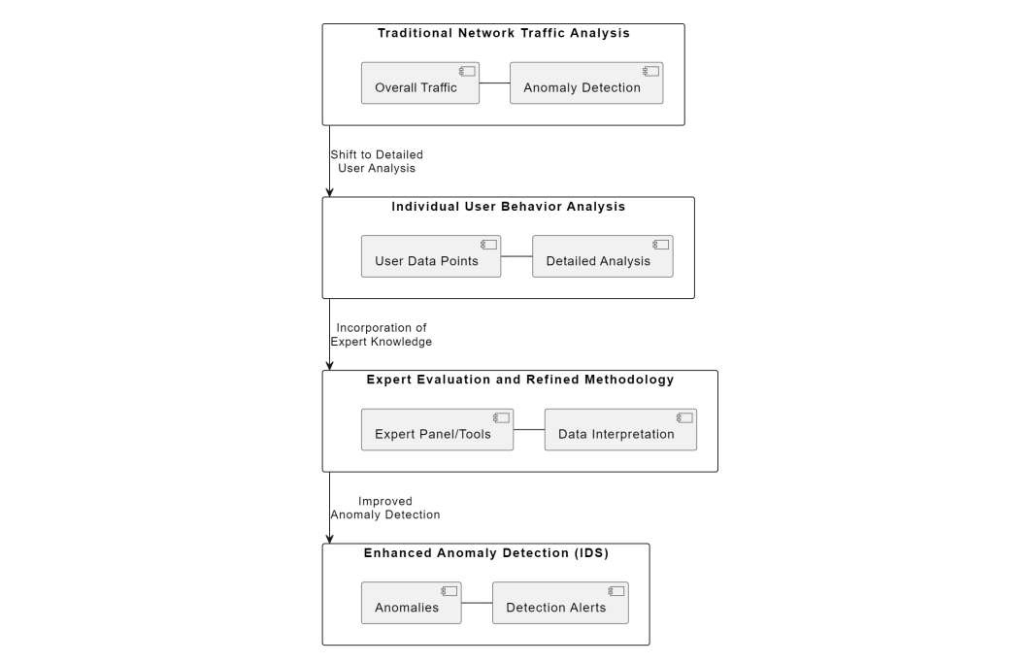
Figure 2.1 Conceptual layers of network security analysis, reproduced from Benova and Hudec (2024)

2.2 Traditional Machine Learning Approaches for Web Log Analysis
Before the recent rise in deep learning, anomaly detection in web traffic was frequently addressed using traditional machine learning methods. In these approaches, manual features are extracted from the web server logs. These features include request frequency, URL length, number of parameters, session duration, response codes, and time-based patterns of access. Classical algorithms then detect anomalies by learning the characteristics of normal traffic and flagging deviations from this behaviour.
Clustering-based approaches, such as k-means, group together similar requests or sessions and consider outliers to be anomalies. These methods can be sensitive to noise, high-dimensional data, and the choice of parameters such as the number of clusters. One-class classification methods, such as one-class support vector machines (SVMs), model normal traffic and identify deviations from this model as anomalies. However, these approaches may be sensitive to feature selection and parameter tuning.
Isolation Forest is a popular traditional anomaly detection algorithm for web traffic. The Isolation Forest algorithm isolates anomalies by randomly partitioning the data. This can be more efficient as anomalous samples require fewer partitions to be isolated than normal ones. It is computationally efficient and does not require labelled attack data for training (Liu et al., 2008). It has been successfully applied to HTTP (Ahmed et al., 2021) and web log anomaly detection tasks.
In general, despite being effective, traditional machine learning methods have several limitations and drawbacks. Manual feature engineering is often time-consuming and may be application specific. These methods limit generalisation across different environments. In addition, traditional models often fail to capture the sequential and temporal aspects of web traffic. This is because most traditional models treat each request independently. However, some attacks might appear normal at the request level but are malicious in the context of a sequence of interactions. Scalability and adaptability are other limitations that traditional models face. In dynamic web environments, new features may be discovered, and traffic patterns may change, requiring frequent retraining and updates to the feature set.
Figure 2.2 illustrates a traditional machine learning–based anomaly detection pipeline using Isolation Forest, adapted from the approach proposed by (Chua 2024). The workflow relies on manual feature generation, data preprocessing, and static model training, highlighting the limitations of traditional methods when applied to evolving web traffic patterns.
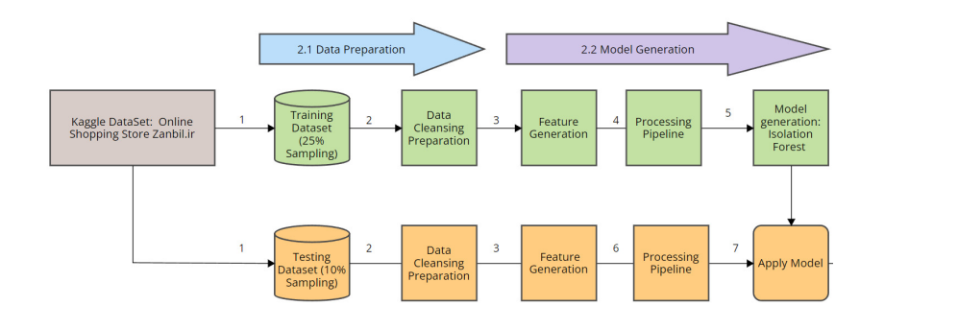
Figure 2.2 A Traditional Isolation Forest–based web anomaly detection workflow ,reproduced from Chua (2024)

2.3 Deep Learning for Web Log and HTTP Traffic Analysis
The limitations of traditional machine learning have also prompted interest in using deep learning for web traffic anomaly detection. Deep learning models can be trained end-to-end on raw web server logs without requiring engineered features, making them more flexible and generalizable to high-dimensional and semi-structured data.
Deep learning has been applied to both request-level and session-level modelling. Request-level models learn representations of individual HTTP requests, while session-level models learn temporal dependencies between requests to capture behavioural anomalies over time. This allows them to effectively detect sophisticated and evolving web attacks.
Embedding-based methods can also be used to convert URLs and request parameters into numerical representations that capture semantic similarities. For instance, using HTTP2Vec and Sec2Vec to learn better representations for anomaly detection has improved the detection of subtle anomalies such as obfuscated payloads and unusual parameter combinations (Gniewkowski, M, 2023).
Deep learning can also be used to model sequential patterns in web traffic, enabling the detection of attacks that use abnormal timing or ordering of requests rather than explicit signatures of malicious content. However, these models are data- and compute-intensive and often lack interpretability. Therefore, choosing architectures that balance detection performance with resource constraints is critical for deployment.
Figure 2.3 illustrates a deep learning–based HTTP request representation pipeline, adapted from the HTTP2vec approach proposed by Gniewkowski et al. 2021. The architecture demonstrates how raw HTTP requests can be tokenised and embedded into dense vector representations using neural
models, enabling both visual analysis and downstream anomaly detection tasks.
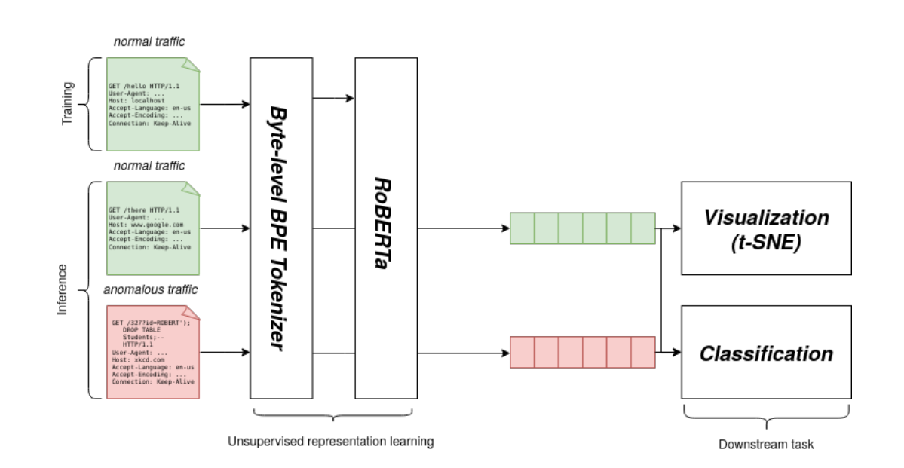
Figure 2.3An HTTP request embedding and deep learning processing architecture , reproduced from Gniewkowski et al. (2021)

2.4 Autoencoders for Content-Based Anomaly Detection
Autoencoders are among the most popular deep learning approaches for anomaly detection, in both unsupervised and semi-supervised settings. Autoencoders typically consist of two sub-networks: an encoder that maps input data to a lower-dimensional latent representation, and a decoder that attempts to reconstruct the original input from the latent representation. The autoencoder is trained to minimise reconstruction error on normal data. As a result, anomalous inputs tend to have larger reconstruction errors.
Content-based autoencoder methods have been extensively used for modelling HTTP requests, including components such as URLs, query parameters, request headers and payloads. These methods are particularly suitable for detecting attacks at the payload level, such as SQL injection, cross-site scripting and directory traversal attacks, which have distinct request content or structures from normal traffic (Wang et al., 2020).
The primary advantage of autoencoders is that they do not require any labelled attack data, only data about normal traffic or benign anomalies. This makes them well suited to the web security deployment, where labelled datasets are frequently incomplete and may not include the latest threats. Autoencoders can learn normal behaviour from historical traffic data and detect previously unseen attacks as deviations from the learned patterns. Reconstruction error is a natural anomaly score which can be thresholder to trade off detection sensitivity and false alarms. Autoencoders have also been shown to perform well in the highly imbalanced regimes that characterise web traffic datasets. Since the model is trained only on normal data, the presence of anomalous examples does not bias learning. In addition, reconstruction-based detection has the advantage of allowing flexible choice of detection threshold based on statistical properties of reconstruction errors, such as a percentile or confidence interval.
On the other hand, content-based autoencoders have a few important limitations. First, they typically operate on individual requests in isolation, without any contextual information. Therefore, they cannot detect attacks that may be based on a sequence of normal-looking requests executed in a suspicious manner or order. For example, web scanners or credential stuffing attacks may perform repeated requests that are individually indistinguishable from legitimate traffic, but which form suspicious patterns when viewed as a sequence over time.
Reconstruction-based anomaly detection has been widely adopted for HTTP traffic analysis due to its ability to model normal request behaviour and identify deviations using reconstruction error. Figure 2.4 illustrates a typical reconstruction-based detection pipeline, adapted from Wasundara et al. 2025 , where HTTP requests are pre-processed, vectorised, and passed through an autoencoder trained on benign traffic. Requests producing high reconstruction error are flagged as anomalous.
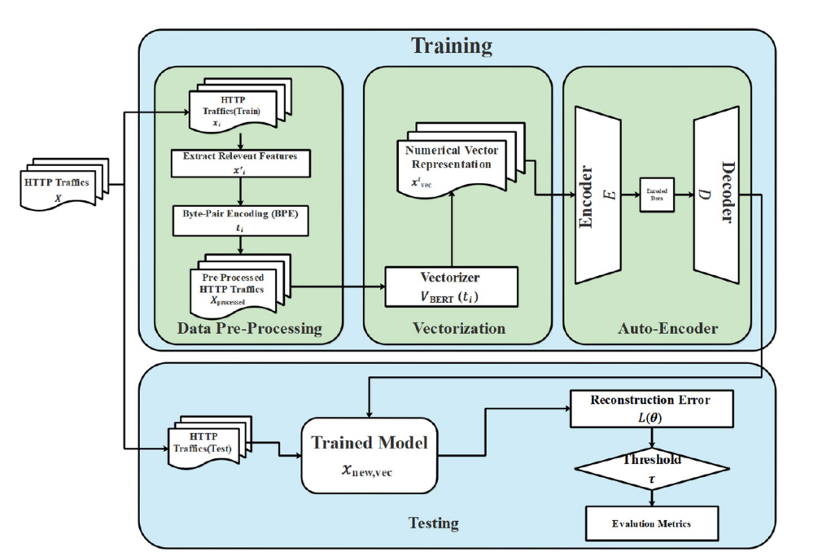
Figure 2.4 Reconstruction-based scoring ,reproduced from Wasundara et al. (2025),

2.5 LSTM Networks for Behaviour-Based Anomaly Detection
Long Short-Term Memory networks, or LSTMs, are a form of recurrent neural network that have been used to model sequence data. Recurrent neural networks are designed to process sequences and are particularly effective at modelling long-term dependencies in sequential data. LSTM networks were developed to address the vanishing gradient problem that can occur with traditional recurrent neural networks. LSTM networks have been used in a variety of applications, including natural language processing, speech recognition, and anomaly detection in web traffic.
In the context of behaviour-based anomaly detection, LSTM models can be used to model user behaviour in web traffic based on sequences of requests within a session. LSTM models can learn normal navigation patterns and relationships between requests, including the order in which requests are made, the frequency of access, and the temporal relationships between requests. Anomalies can then be detected based on deviations from these learned patterns. LSTM models have been shown to be effective at detecting attacks that occur over multiple requests, such as scanning, brute-force, and automated exploitation (Du et al., 2017).
In addition to the use of LSTM models for behaviour-based anomaly detection in web traffic, several other studies have proposed the use of autoencoder or variational autoencoder architectures in combination with LSTM. LSTM-based autoencoders are trained to reconstruct normal sequences, while LSTM variational autoencoders model normal behaviour probabilistically and incorporate uncertainty into the anomaly detection process (Zhang et al., 2021). These models have been shown to outperform traditional sequential models in terms of detection performance for complex behavioural anomalies.
However, LSTM-based models for behaviour-based anomaly detection in web traffic have a few limitations. For example, the performance of these models is dependent on the quality and length of the session data that is available. If sessions are short or fragmented, the models may not be able to learn meaningful behavioural patterns. In addition, LSTM models can be computationally expensive to train and deploy, which can be a challenge when working with large-scale web traffic datasets. Noise in the session data, such as irregular user behaviour or automated clients, can also affect model performance.
As a result of these limitations, behaviour-based models may be best applied in combination with other detection approaches. For example, LSTM-based behavioural modelling can be combined with content-based analysis to provide a more complete picture of web traffic and improve detection robustness.
Session-based anomaly detection has been explored as a means of identifying malicious behaviour that emerges across sequences of HTTP requests rather than individual payloads. Figure 2.5 illustrates a session-based deep learning architecture adapted from Liu et al. 2019, where HTTP requests are analysed collectively using a neural network to capture behavioural patterns. This approach highlights the importance of modelling temporal dependencies between requests, particularly for detecting multi-step attacks that may evade content-based inspection alone.
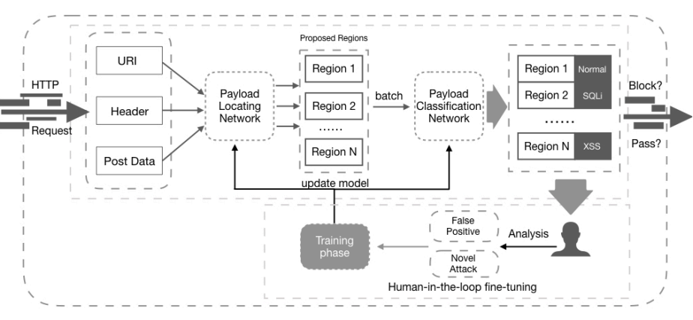
Figure 2.5 Session-based LSTM architecture , adapted from Liu et al. (2019)

2.6 Limitations of Single-Model Detection Approaches
Although the research works that are published in the previous sections show the individual advantages of both content-based and behaviour-based approaches, several of them also acknowledge a few limitations of the application of a single detection model. In the real world, recent and advanced attack methods are much stealthier than the previous ones. It is commonly accepted that no individual perspective can suffice to obtain complete visibility. These limitations can be summarised as follows.
Content-based models, such as autoencoders, that analyse request payloads individually, work well for detecting anomalies that represent malformed inputs, abnormal values or subversive contents and request structures. However, several real attacks would not be detected by such models, as they use valid requests. This is the case of automated scanning attacks, but also credential stuffing, slow-rate probes, or low and slow attacks that usually do not produce content-based anomalies. This limitation is also related to the short-sightedness of content-only models: single requests with valid structure and malicious purpose can be given low anomaly scores.
Behaviour-based detection models can detect more complex attack patterns, as they analyse sequences of requests and learn typical user interactions in the web application. For example, LSTM-based models can be used to detect abnormal navigations or request timing. However, behaviour-based models have their own limitations as well. They are strongly dependent on the quality and length of sessions, as they can perform poorly if sessions are short, noisy or interrupted. They also can yield false positives as legitimate users can behave in a very erratic way. In addition, another important limitation of single-model approaches is concept drift. Single detection models are affected by application changes and need to be retrained when software is upgraded, new features are added or user behaviour changes. However, this is an issue that can be alleviated if different types of signals complement each other.
The issues described above also reflect the operational challenges for the use of single-model systems. As has been mentioned several times in the previous sections, high false positive rates can rapidly reduce analysts’ trust and willingness to use automated detection. Operational environments for security are usually much more complex, and security operations teams prefer reliable and high-quality alerts over the maximisation of detection rates even at the cost of increased noise.

2.7 Hybrid and Fusion-Based Anomaly Detection
Hybrid and Fusion-Based Approaches. To overcome the limitations of single-model approaches, researchers have turned to hybrid and fusion-based anomaly detection frameworks. Hybrid systems integrate multiple detection models, each focusing on different facets of web traffic, such as request content and user behaviour. Fusion-based methods then combine the outputs of these individual models to produce a final anomaly score or decision. This approach capitalizes on the complementary nature of different detection signals, allowing them to reinforce each other and leading to more robust and generalizable systems.
Empirical evidence from the literature suggests that hybrid anomaly detection frameworks outperform single-model systems in complex and dynamic environments. In one study, the authors showed that combining content-based autoencoders with behaviour-based LSTM models resulted in a system that can detect both payload-level anomalies and temporal behavioural deviations (Khan, N. W., 2023). This dual perspective is particularly useful for identifying attacks that would otherwise be missed if only one view is considered.
The fusion strategies employed in various studies can range from simple score averaging to more complex ensemble techniques. A common approach in the literature is threshold-based fusion, where the outputs of different models are combined and compared against predefined thresholds to determine whether an event is anomalous or not. Threshold-based fusion strategies have the advantage of being easy to implement and interpret, and they also offer flexibility in tuning detection sensitivity to operational requirements, such as low false positive rates.
In addition to enhancing detection performance, hybrid approaches have been shown to improve detection stability across datasets with different characteristics. Web traffic datasets can vary widely in their format, scale, and traffic composition, which can have a significant impact on model performance. By integrating multiple detection models, hybrid systems reduce the reliance on dataset-specific features and become more resilient to variations in traffic patterns (Khan, N. W., 2023).
This makes fusion-based approaches particularly well-suited for real-world deployment, where consistency and reliability are key requirements. One should note, however, that while hybrid detection frameworks offer several advantages, they also introduce additional system complexity. Designing effective fusion mechanisms requires careful calibration to balance detection sensitivity and false positives. In some cases, poorly tuned fusion strategies may amplify noise or even mask useful signals. Furthermore, hybrid systems may also require more computational resources and careful coordination between model components. These challenges underscore the need for systematic evaluation and thoughtful system design when developing hybrid anomaly detection solutions.
Hybrid anomaly detection frameworks have been proposed to combine multiple detection perspectives into a single decision pipeline. Figure 2.7 illustrates a hybrid detection architecture adapted from Kamal et al. 2025, where data preprocessing, feature normalisation, model training, and validation are integrated into a unified workflow. This design highlights the benefits of combining multiple detection stages to improve robustness and control false positives, which aligns with the motivation of the proposed hybrid framework presented in this study.
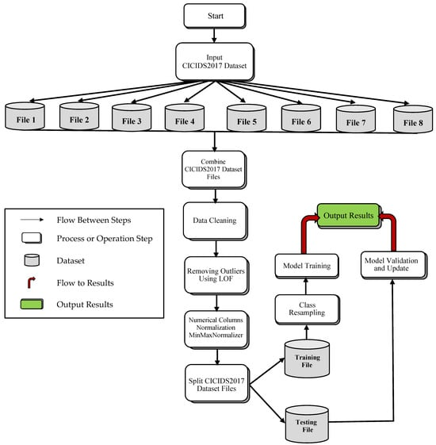
Figure 2.7 Hybrid anomaly detection architecture, adapted from Kamal et al. (2025)

2.8 Summary and Research Gap
The reviewed literature provides valuable insights into the evolution of anomaly detection approaches for web server logs. We have observed a transition from traditional rule-based systems to advanced machine learning (ML) and deep learning (DL) methods. While conventional ML approaches form a solid foundation, their feature engineering requirements and limited temporal modelling capabilities have driven the adoption of DL techniques, including autoencoders and LSTM-based models. Autoencoders have shown promise for content-based anomaly detection, particularly in highly imbalanced scenarios, while LSTM-based models have excelled in capturing behavioural patterns and detecting evolving anomalies.
Nevertheless, the literature consistently emphasises that relying on a single model or approach is insufficient for robust and reliable anomaly detection in real-world web environments. Single-model systems often struggle with challenges such as concept drift, behavioural variability, and operational constraints, including false positive control. In response to these challenges, hybrid and fusion-based detection frameworks have emerged as a promising avenue for research and development. By combining the strengths of content-based and behaviour-based models, hybrid approaches offer a more comprehensive and nuanced representation of web traffic, leading to improved stability and detection performance across datasets and operational environments.
While the existing studies provide evidence of the potential of hybrid approaches, they often evaluate their methods on limited datasets or focus predominantly on detection accuracy rather than operational suitability. There is a clear research gap in the systematic evaluation of hybrid DL frameworks for web server log anomaly detection across datasets of varying sizes and formats. This evaluation should prioritise metrics and considerations aligned with operational suitability, including precision, low false positive rates, and ease of deployment and integration. In this study, we propose a fusion-based anomaly detection framework that combines the strengths of content-based and session-based DL models. We will assess the performance of this framework using metrics that are better suited to highly imbalanced data and that provide a more comprehensive assessment of operational suitability.

CHAPTER 3 - Research Design and Methodology

3.1 Introduction
This chapter describes the research design and methodology used to create and evaluate the web server log anomaly detection framework proposed in this thesis. It provides an overview of how the proposed approach can meet the research aims and objectives presented in Chapter 2 and set out in the research questions below. The main purpose of this chapter is to describe how the research is conducted, including how data is collected or curated, what models are designed, how the experiments are carried out, and how results are evaluated. The intended outcome of this chapter is to present a research methodology that is technically appropriate, reproducible, and practically relevant to real-world security use cases.
The research in this thesis follows an experimental and design-oriented methodology, in which a hybrid deep learning framework is implemented and tested on real and semi-synthetic web server log datasets. The research methodology draws on several research paradigms and techniques, including semi-supervised learning, deep neural network modelling, and empirical evaluation using appropriate performance metrics for highly imbalanced data. Practical considerations such as limited labelled data, scalability, and false positive control are also emphasised for operational relevance.
The overall chapter structure is as follows: First, we provide an overview of the research approach, then we present the details of the dataset selection, data preprocessing, model architecture, training strategy, and evaluation methodology. Then, we discuss how the proposed framework combines content-based and behaviour-based anomaly detection, and how the experimental results are generated and analysed.

3.2 Research Approach
The methodology in this research is primarily quantitative and experimental. The study is designed to develop and evaluate a deep learning–based anomaly detection framework for web server logs. Instead of focusing on theoretical model formulation, the emphasis is on practical implementation and empirical evaluation using real log data.
The objective is to assess the effectiveness of the proposed framework in realistic operational settings. The learning paradigm employed is semi-supervised learning. The models are trained on normal web traffic, and there is limited or no use of labelled attack data. This reflects practical scenarios, where benign traffic is typically abundant, but labelled malicious data is scarce or unavailable. Semi-supervised anomaly detection is well-suited for web security, as it can detect novel attacks based on deviations from the learned representation of normal traffic.
The study design can be characterised as a comparative evaluation approach. Individual detection models are first evaluated in isolation, and their performance is later combined in the hybrid framework. This allows the contribution of each model component to be understood and provides insights into the strengths and weaknesses of content-based, behaviour-based, and fused detection approaches. By evaluating performance across multiple datasets, the robustness and generalisability of the proposed framework are assessed.

3.3 System Overview and Detection Pipeline
The architecture of the proposed system is modular, including components for data preprocessing, feature extraction, model training, anomaly scoring, and fusion-based decision making. The entire pipeline is illustrated in Fig. 3.3 below. Input data to the system are raw web server log records, which are pre-processed to extract relevant attributes and transform them into a format suitable for deep learning models. Data preprocessing involves parsing log records, handling missing or noisy entries, and normalizing or encoding features as necessary.
Feature extraction includes both content-based and behaviour-based representations. In the content-based branch, individual HTTP requests are profiled using structural and semantic features. In the behaviour-based branch, web sessions are reconstructed based on client identifiers and temporal thresholds, and the sequences of requests within each session are encoded.
Model training is performed separately for the content-based and behaviour-based models. The content-based model is an autoencoder trained to reconstruct normal request profiles, while the behaviour-based model is an LSTM-based variational autoencoder trained to model the sequential nature of web sessions.
Anomaly scoring involves computing reconstruction errors or probabilistic deviations from the learned distributions for both the content-based and behaviour-based models. These scores represent the degree of abnormality at both the request and session levels.
Finally, fusion-based decision making combines the anomaly scores from the two models using a predefined strategy (e.g., weighted averaging or max pooling) to produce a single, fused anomaly score. A threshold is then applied to this score to generate the final detection decision.

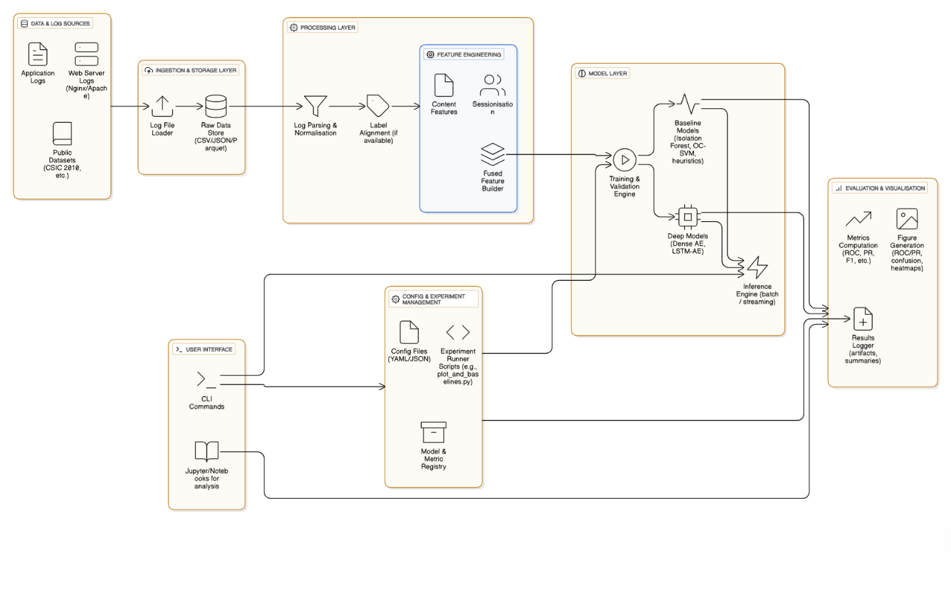
Figure 3.3 Proposed Web Server Log Anomaly Detection Pipeline Architecture

3.4 Dataset Selection and Data Sources
The datasets used in this paper are chosen to represent real-world web server logs and allow us to test the proposed framework under different conditions. We include both structured and semi-structured log formats to test the generalisability of the approach. Datasets with mixed benign and malicious traffic are also used to evaluate detection performance. In terms of size, structure, and complexity, the datasets are carefully chosen to represent different scenarios.
One of the primary criteria is the presence of semi-structured and unlabelled Apache access logs that are prevalent in real-world web servers. These logs contain various fields, such as request methods, requested URLs, response codes, timestamps, and client IP addresses. Semi-structured log analysis requires careful parsing and preprocessing, making it a suitable choice for evaluating practical anomaly detection systems. To ensure generalisability and compatibility with modern logging standards, we also include structured Nginx JSON logs. These logs share similarities with Apache logs but are stored in a structured JSON format.
Structured logs are more straightforward to parse and extract features from, and Nginx JSON logs are becoming increasingly popular in web infrastructures. The inclusion of both log formats allows us to evaluate the proposed framework’s performance across different logging standards.
The datasets also comprise both benign traffic and labelled malicious activity to ensure a realistic mix of traffic. This allows for controlled evaluation of detection performance while maintaining a realistic class imbalance ratio. The use of different datasets with varying sizes enables us to study the impact of dataset scale on model performance and stability.

3.5 Data Preprocessing and Parsing
Raw web server logs need to be pre-processed before using for deep learning–based anomaly detection. The preprocessing step includes log parsing, dealing with missing or malformed data, normalising numerical values, and transforming text features into numerical form that can be used by models.
Parsing access logs involves extracting request method, URL path, query parameters, response code, timestamp, and client identifier. For Apache logs, regular expressions and log parsing libraries can be used to transform unstructured log lines into structured records. For Nginx JSON logs, parsing is more straightforward since the data is already structured, but validation of the log entries is necessary.
Normalising numerical features ensures that model training is stable. Categorical features such as HTTP methods and response codes are encoded into numerical representations. Textual elements such as URLs and parameters are tokenised and converted into fixed-length vectors to allow content-based modelling.
Noise and outliers in normal traffic need to be handled so that the models are not biased. Requests with missing critical information or corrupted fields are removed to ensure data quality. Preprocessing is done in the same way across datasets to allow fair comparisons.

3.6 Session Construction and Behavioural Representation
Behavioural modelling is based on sessions which are logical constructs that correlate a set of individual requests that a user is making to the application. In this research, the session is constructed by identifying requests coming from the same client (IP address and user-agent string) and when those requests are less than the threshold delta time away. The session timeout values must be carefully chosen to best aggregate requests into meaningful behaviour and de-noise the data. Choosing a threshold that is too short would cause sessions to split into multiple parts even if they are likely to be the same user. A value too long would mix unrelated behaviour together. We enforce the same threshold across datasets to compare results fairly. Once the sessions are formed, each request in the session is treated as part of a sequence in which both ordering of the requests and the relative time information are preserved.
Requests within sessions are mapped into numeric representations that can be inputted into the sequential model. Features that are considered include the various encoding of requests such as the method, response status, resource type as well as the time difference between requests within a session.

3.7 Feature Representation and Input Preparation
Feature representation is an important factor for model performance. In this research, different feature representations are employed for content-based and behaviour-based analyses to capture distinct aspects of web traffic data. Each model has a dedicated feature preparation pipeline that works with features relevant to its detection goal.
In content-based analysis, features are extracted from individual HTTP requests. URL paths and query parameters are tokenised and represented as fixed-length numerical vectors. Simple tokenisation and encoding techniques are used to process textual fields without introducing unnecessary complexity and while retaining interpretability. Numerical features, such as the number of parameters and payload lengths, are normalised to facilitate stable training.
In behaviour-based analysis, features are aggregated into sessions and combined with request-level representations and temporal information. Sessions are modelled as sequences of vectors, where each vector corresponds to a single request. Time intervals between requests are incorporated to capture the pacing of interactions. Padding and truncation are applied to ensure consistent sequence lengths suitable for batch training.
Special care is taken to ensure that feature preparation does not inadvertently introduce label information into the training process. All models are trained only on normal traffic and malicious labels are only used for evaluation purposes. This choice was made to preserve the integrity of the semi-supervised learning approach.
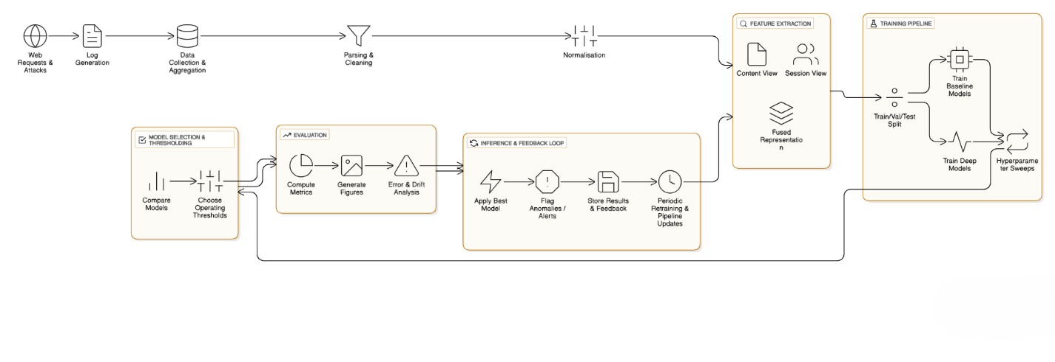
Figure 3.7 Proposed Input Pre-processing and Feature Extraction.

3.8 Content-Based Autoencoder Architecture
To implement the content-based anomaly detection sub-component of our proposed framework, we use an autoencoder neural network to learn a low-dimensional representation of the normal request content. The network is trained by minimizing reconstruction error of the HTTP request contents.
We use a simple feed-forward neural network for our autoencoder model. The encoder consists of fully connected layers that map the input features to a low-dimensional latent space, and the decoder is another fully connected stack of layers that maps the latent representation back to the original input dimensions. The encoder maps the input to a latent representation, through a few fully connected layers with decreasing size. We use a non-linear activation function on each encoder layer, allowing the model to learn a complex, non-linear relationship between input features. The decoder mirrors the encoder architecture, using fully connected layers with increasing size to reconstruct the original input from the latent representation. We use mean squared error between the reconstructed output and the original input as our reconstruction loss function, as it provides a simple, interpretable metric for reconstruction quality.
The autoencoder is trained only on normal traffic so the latent space should capture normal request patterns. At inference time, we can compute a reconstruction error for each request, which can serve as our anomaly score. Anomalous requests are those whose reconstruction error surpasses a threshold.

3.9 Behaviour-Based LSTM Variational Autoencoder
To represent sequential user behaviour, this research utilises an LSTM-based variational autoencoder. The LSTM variational autoencoder model combines the sequential modelling of LSTM networks with the probabilistic representation learning of variational autoencoders. The architecture is structured to capture normal session-level behaviour and identify anomalous sequences that deviate from learned distributions.
The encoder in the model consists of LSTM layers that process sequences of request vectors. The final hidden state of the LSTM is used to parameterise a latent distribution with a mean vector and a variance vector. A sampling step generates latent variables from this distribution, incorporating controlled stochasticity into the model. The decoder employs LSTM layers to reconstruct the original request sequence from the sampled latent representation.
The training objective incorporates reconstruction loss and a regularisation term based on the Kullback–Leibler divergence. This regularisation term encourages the model to learn a smooth and continuous latent space while maintaining reconstruction accuracy. The explicit modelling of uncertainty through the LSTM variational autoencoder allows for a more robust capture of normal user behaviour variability.
During inference, anomaly scores are derived from both reconstruction loss and deviation from the learned latent distribution. Sessions that deviate significantly from normal behavioural patterns are assigned higher anomaly scores.

3.10 Model Training Strategy
The content-based autoencoder and the behaviour-based LSTM variational autoencoder are both trained in a semi-supervised learning manner. Only normal web traffic is used during training, allowing for the model to learn a representation of normal behaviour. Any malicious traffic is saved to be used later for evaluation. The models are trained using mini-batch gradient descent with adaptive optimisation, as well as early stopping for generalisability. Hyperparameter search is done empirically, with learning rate, batch size and latent dimension size chosen by trial and error based on validation performance. The same training process was used for all datasets to ensure comparability of results, with model checkpoints being saved for reproducibility.

3.11 Pseudo-Code for Model Training and Detection
The pseudo-code in Algorithm 1 shows a high-level overview of the training and inference phases for the proposed anomaly detection framework.
Overview of the training and inference phases:
The training phase consists of two components: content-based autoencoder and behaviour-based LSTM variational autoencoder.
For the content-based autoencoder, the model is initialized with random weights. It is then trained using the normal request data. The training process involves passing batches of request feature vectors through the encoder and decoder. The reconstruction loss is computed, and the model parameters are updated accordingly. This process is repeated for multiple epochs or until the convergence or early stopping criteria are satisfied.
For the behaviour-based LSTM variational autoencoder, session sequences are created using the normal traffic data. The LSTM encoder processes these sequences, and latent variables are sampled. The decoder then attempts to reconstruct the input sequence using the sampled latent variables. The reconstruction loss and divergence loss are computed and combined to update the model parameters. This process is repeated iteratively until the model achieves stable performance.
q(z | x) = N(μ, σ²)
p(z) = N(0, I)
The anomaly detection phase involves inference on incoming requests and sessions using the respective trained models. The reconstruction error and probabilistic deviation are calculated for each instance and then transformed into anomaly scores. The anomaly scores are then fed to the fusion module for final decision-making.
In addition to reconstruction error, the LSTM variational autoencoder calculates behavioural anomalies based on a probabilistic distance to the normal behaviour in the latent space. This is the Kullback–Leibler divergence between the distribution of the learned latent representation and a standard normal prior. If a session's latent representation is a greater distance from the distribution of the learned normal behaviour, it results in a greater KL divergence and is assigned a higher anomaly score.
DML(q(z | x) || p(z)) = 1\2 Σ ( μi² + σi² − log(σi²) − 1 )
Sbehaviour = α · Lrecon + (1 − α) · DKL

3.12 Fusion Mechanism and Decision Strategy
Content-based and behaviour-based models are combined using a fusion mechanism which produces a final anomalous traffic detection signal. Fusion has been chosen as a suitable mechanism to merge complementary detection signals produced by the two base detectors, with the aim of recognising both request-level and session-level behaviour that deviates from the norm. Fusion is a powerful strategy to reduce reliance on one detection view (content-based or behaviour-based) since reliable anomaly detection across both views is a challenge using a single model.
Score-level fusion has been used for the proposed anomaly detection framework. In score-level fusion, scores of the same type from multiple models are combined [121]. In the case of the proposed anomaly detection framework, the content-based autoencoder model produces a reconstruction-based anomaly score per HTTP request. The behaviour-based LSTM variational autoencoder model produces a reconstruction-loss and probabilistic distribution-based anomaly score per session. Each of these scores is normalised and a final aggregated anomaly score per session is calculated from the combination of scores.
In the case of this study, a simple aggregation fusion strategy has been used to prioritise stability and interpretability of the anomaly detection framework. An alternative approach would have been to ensemble learning. The purpose of ensembling models is to train each base model using a different optimisation objective which are then later aggregated during inference for improved detection stability and accuracy. The difference in the proposed framework is that a simple approach is used to aggregate the anomaly scores from the two base detectors. This has the advantage of making the behaviour of the fusion mechanism easier to understand, which in turn makes it easier to tune to a given operational requirement.

3.13 Threshold Selection and Anomaly Labelling
Threshold selection is a design decision related to the operating characteristics of anomaly detection systems. For this study, thresholds are derived by means of statistics on the distribution of the anomaly scores obtained on normal training data. Percentile-based thresholding is applied to decide on decision thresholds that are aligned with the distributions of normal scores.
For the individual models and the fused anomaly score, thresholds are based on high-percentile values of reconstruction error and deviation scores to control for sensitivity and avert high false positive rates. The requests or sessions that register anomaly scores above the set threshold are marked as anomalous.
Percentile-based thresholding has been chosen with respect to its practical implications for deployment. In security use-cases with very imbalanced datasets, inundating analysts with false alarms from over-sensitive anomaly detectors can erode trust in the detection systems. The proposed framework is calibrated to be conservative in terms of precision-recall trade-offs, and the emphasis on lower false positive rates is intended to ensure that the anomalous events that are flagged are more likely to be real.

3.14 Experimental Setup and Implementation Environment
Evaluation is performed on a fixed implementation to make sure that results are reproducible and consistent. All experiments are run with the same hardware and software configuration to prevent external factors from causing variability in results. The models are implemented using popular deep learning frameworks for transparency and reproducibility.
The training and evaluation splits of the datasets are performed following the semi-supervised learning setting. Only normal traffic is used for training while benign and malicious requests are used in the evaluation split. The split of the datasets is made this way to make sure that the model performance reflects its ability to detect unseen anomalies, rather than memorising known attack patterns.
The training and the inference are done with the batch processing of log records to be able to process large amounts of data. Intermediate outputs are saved during processing, which includes anomaly scores, predictions and any other information that would be useful in analysis. Training and experimentation processes are logged to trace the progress and record the settings for systematic comparisons between experiments.

3.15 Evaluation Metrics and Performance Measurement
Web intrusion detection models and systems should be assessed with appropriate measures of performance. As anomaly detection was applied to highly imbalanced data in this research, we do not use accuracy as a key performance indicator in our results and discussion. Precision was utilised to measure the percentage of predicted anomalies that were true intrusions, which will be useful in determining the suitability of the models for operational deployment by assessing the reliability of alerts generated. Recall was used to quantify the percentage of true anomalies that were detected by the system. The false positive rate is also evaluated. To compare performance across different threshold settings, receiver operating characteristic curves and precision–recall curves were generated for each model. Area under the curve values is then calculated and discussed for each model (content-based, behaviour-based and fused). Precision–recall analysis is of particular importance in the context of web security, due to the high degree of class imbalance that is typically observed.

3.16 Reproducibility and Validity Considerations
Reproducibility and validity have been taken into consideration in our experiment. For reproducibility, we ensure the same preprocessing for all datasets. We also fix the training configuration for experiments and use detailed and clear descriptions to explain the settings we use. To remove random seeds and decrease the variation in model training, we control the random seeds wherever possible.
Internal validity has been considered through using the same training and evaluation settings across datasets. This ensures that any observed differences in performance are not due to methodological differences but to differences in the datasets. External validity is also considered by applying the proposed framework to more than one dataset, with different sizes and log formats, and describing the results in terms of generalisability. The study does include some threats to validity, including potential dataset bias, incompleteness of attack coverage and the general limitations of semi-supervised learning. These have been acknowledged and factored into the interpretation of the results. By considering realistic evaluation settings and operationally relevant metrics, we believe the results of the research are meaningful and credible.

3.17 Summary of Methodology
This chapter has described the overall research design and methodology adopted to develop and validate the proposed hybrid anomaly detection framework. The methodology encompasses a range of design and implementation considerations, including the choice of semi-supervised deep learning models for content-based and behaviour-based analysis, the fusion mechanism for integrating their outputs, as well as the data preprocessing, model design and training strategy, threshold selection, and evaluation metrics.
The methodological choices made in this study are informed by both academic and practical considerations. By prioritising metrics such as precision, low false positive rate, and generalisability, the proposed framework is designed to meet the needs of real-world web security environments.
The next chapter details the implementation and deployment aspects of the system, providing insight into how the proposed methodology is put into practice.

CHAPTER 4 - Implementation and Deployment

4.1 Introduction
This chapter outlines the implementation and deployment details of the proposed hybrid anomaly detection framework for web server logs. While Chapter 3 focused on the research design and methodology, this chapter shifts the attention to the practical aspects of how the system is realised. The software components, data flow, and overall operational behaviour of the detection framework are discussed in detail. The goal of this chapter is to demonstrate how the proposed approach can be instantiated as a working system suitable for real-world deployment in web security monitoring.
The emphasis is placed on ensuring that the implementation is modular and flexible, such that the different components of the system can be used independently of each other while still allowing for a unified detection pipeline. This should allow for support of multiple log formats, adaptability to different dataset sizes, and robustness to shifting traffic patterns. Practical aspects, including efficiency, maintainability, and reproducibility, are also taken into consideration throughout the implementation process.

4.2 Development Environment, Software Stack, and Testbed Configuration
The proposed method was implemented and evaluated within an integrated software and testbed environment that provided realistic data generation, processing and analysis components. The complete workflow is outlined in Figure 3.3 and comprised controlled traffic generation within a virtualised testbed, data preparation, anomaly detection, and result visualisation.
The development environment consisted of a Windows host system, with Ubuntu virtual machines created within Oracle VirtualBox for simulating web server and client activity. Virtualisation was used for isolated and reproducible experimentation, which did not impact the host machine, and is commonly used for cybersecurity research (Scarfone & Mell, 2012). The testbed itself comprised Ubuntu Linux for running web services and monitoring tools, with Snort used as an intrusion detection system that could be used to support the controlled generation of benign and malicious traffic (Roesch, 1999). Application-level traffic was logged using Apache and Nginx, resulting in realistic web server log data.
Log files were processed using custom Python scripts to parse requests, extract features, and form sessions based on client identifiers and timing information. Cleaning and normalisation were performed to ensure consistent formatting between datasets. Python was chosen as the primary language for implementation due to its extensive support for data processing and machine learning, especially within cybersecurity research (Shiravi et al., 2012).
Pre-processed data was then used to extract content-based features, which were input to the autoencoder for analysis. Session-based features were fed to the LSTM variational autoencoder for modelling temporal behaviour. Both models were implemented using TensorFlow and Keras libraries, which provided efficient training and simplified model development (Abadi et al., 2016). Model anomaly scores were fused and thresholder to produce the final detection decisions, with Scikit-learn supporting the normalisation and evaluation tasks.
Evaluation results were then presented and visualised using Matplotlib and Seaborn for generating ROC curves, precision–recall plots, heatmaps, and score distributions. All components were managed within a Python virtual environment, with Git providing version control for reproducibility.
Summary of overall software development environment used while conducting this research is as follows in table 4.2:
Category | Tool / Technology | Purpose
Host Operating System | Windows 11 | Primary development and experiment orchestration
Virtualisation Platform | Oracle VirtualBox | Hosting Ubuntu-based testbed virtual machines
Guest Operating System | Ubuntu Linux | Testbed environment for traffic generation and monitoring
Network Monitoring | Snort IDS | Capturing and generating labelled malicious and benign traffic
Traffic Generation | Custom Scripts / Replay Tools | Simulating normal and attack-oriented web traffic
Programming Language | Python 3.12 | Core implementation of detection pipeline
Deep Learning Framework | TensorFlow / Keras | Autoencoder and LSTM-VAE model development
Data Processing | Pandas, NumPy | Log parsing, feature extraction, sessionization
Machine Learning Utilities | Scikit-learn | Evaluation metrics and threshold calibration
Visualisation | Matplotlib, Seaborn | Performance and behaviour visualisation
Dataset Preparation | Custom Python Scripts | Log cleaning, parsing, labelling, and aggregation
Environment Management | Python Virtual Environment (venv) | Dependency isolation
Version Control | Git | Source code and experiment management
Development Tools | Visual Studio Code | Coding and debugging

In addition to publicly available datasets, a controlled testbed environment is supported for realistic data generation and validation. Ubuntu-based virtual machines are provisioned with Oracle VirtualBox to simulate a web server environment and client interactions. Snort is configured as an intrusion detection system in the testbed to facilitate labelled benign and malicious event generation. This approach allows for controlled traffic generation, enabling the capture of diverse request patterns and attack behaviours. Logs collected from this environment are post-processed with custom Python scripts and merged with external datasets for consistency and realism in experiments.

4.3 System Architecture Overview
The discussed system is implemented as a pipeline that is composed of a set of separate modules. Each module encapsulates a specific phase of the anomaly detection processing, such as raw log ingestion and preprocessing, feature extraction, model inference, scoring, and decision making. The design of the system architecture is layered, where each module represents a layer. This design enables the flexibility to update or change any of the components without impacting the other components.
At the input of the system, a stream of web server log messages is ingested from log files that are generated by Apache or Nginx servers. The processing is done in batches to enable offline log analysis, but the components could also be deployed in a near-real time setup. Parsed logs records are then converted to a structured record type and are passed to the preprocessing component.
Separate processing pipelines are used for the content-based and the behaviour-based phases. In the content-based pipeline, individual HTTP requests are processed, and the pre-processed request features are fed to the autoencoder model. In the behaviour-based pipeline, sessions are constructed and sequences of requests are pre-processed and fed to the LSTM-based variational autoencoder model. The outputs of both the models are passed to a fusion module that provides the final anomaly scores and detection decisions.
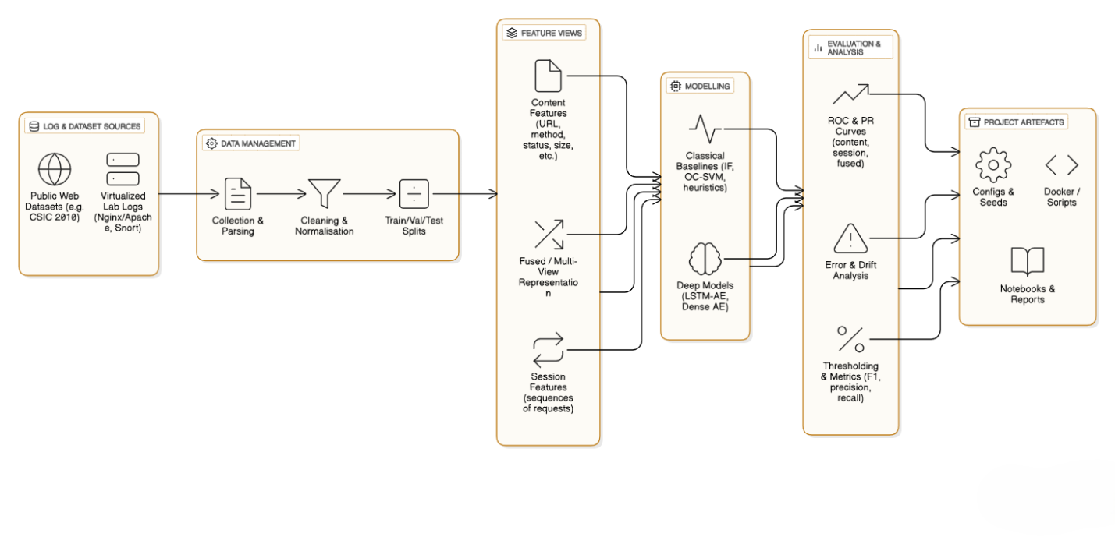
Figure 4.3 Proposed End to End System Architecture Diagram.

4.4 Log Ingestion and Parsing Implementation
Log ingestion is set up to ingest Apache access logs as well as structured Nginx JSON logs. The code reads log files line by line, and delegates parsing to format-specific functions that return extracted fields. For Apache logs, parsing is done using regular expressions and standard libraries to extract fields like request method, URL path, query parameters, response status, timestamp, and client identifier. For Nginx JSON logs, parsing is more straightforward using standard JSON libraries, which also helps in easily validating fields.
Error handling involves discarding entries with malformed or missing critical fields. The logger also logs any anomalies for monitoring and debugging. When possible, default values are assigned to entries with minor inconsistencies.
The parsed log entries are converted to a common internal representation, which abstracts away the differences in the input formats. This common representation includes only the fields that are used later in the pipeline. This way, the same feature extraction and modelling logic can be applied to different types of logs. The parsing logic is decoupled from the model-specific processing.

4.5 Feature Extraction and Data Preparation
The two analysis methods are distinct from each other as they have different aims in detection. The content-based analysis requires extraction of features at the request-level, so features are extracted from single HTTP requests. URL paths and query strings are tokenised and subsequently encoded as fixed-length numerical vectors. Simple encoding strategies are chosen to keep the model interpretable and from being too complex. Numerical features such as request length and number of parameters are scaled to bring values into a normalised range to stabilise the model inference. Categorical features like the HTTP method and response status code are mapped to numerical encodings. The features are stored as arrays of feature vectors, which can be processed in batches by the autoencoder model.
Behaviour-based analysis involves constructing sessions of requests before feature extraction can occur. Requests from the same client IP that fall within a time threshold of inactivity are binned into a session. Sessions are represented as an ordered sequence of the request feature vectors. The sequences are kept in temporal order. Padding and truncating strategies are used to standardise the length of the sequences for the LSTM.

4.6 Model Integration and Inference Workflow
Trained deep learning models are saved as independent inference modules in the system. The content-based autoencoder module takes request feature vectors as input and calculates reconstruction errors for individual requests. These errors are transformed into anomaly scores which indicate the level of deviation from typical request content. The behaviour-based LSTM variational autoencoder module ingests session sequences and calculates reconstruction loss and probabilistic deviation scores. These values are aggregated to produce session-level anomaly scores. Both inference modules are implemented to support batch inference to process very large log files. Inference is implemented to minimise overhead and facilitate reproducibility. Pretrained model weights are loaded on runtime, and inference parameters are fixed to produce consistent results between experiments. Intermediate outputs are stored, including anomaly scores and reconstruction losses.

4.7 Fusion Module Implementation
The final module is the fusion module, whose role is to use the outputs of the two detectors to make a final decision. In the current implementation, fusion is performed after the content-based and behaviour-based models have separately analysed the log data and provided anomaly scores as outputs. This allows each model to be standalone while allowing the final decision to be informed by two complementary sources.
Content-based anomaly scores are at the request level while the behaviour-based scores are at the session level. These two sets of scores need to be aligned to be fused. The system maps request-level scores to the session they belong to. This is also performed in reverse for session-level anomaly scores, which are propagated to the requests in the same session. This process will align scores at the same granularity and allow the system to make inferences about anomalies from both models' points of view at the same time.
Prior to fusion, the anomaly scores are normalised. This is done to ensure that the scores are in the same scale, which is important as reconstruction errors and probabilistic deviations are not on the same numerical scale. Statistical normalisation is applied to the anomaly scores using the distribution of the scores seen during training. This ensures that one model does not overshadow the other because of scale.
The fused anomaly score is a simple aggregation of the normalised content-based and behaviour-based anomaly scores. This strategy was chosen as it is interpretable and robust as opposed to more complicated ensemble methods.

4.8 Threshold Application and Decision Generation
Once the fused anomaly scores have been calculated, the system performs thresholding to decide whether a given request or session should be considered anomalous. The system selects thresholds using a percentile-based thresholding method that chooses a threshold according to anomaly score distribution seen on normal training data. This enables the system to tune the detection sensitivity with low false positive rates.
In evaluation and deployment, we use a pre-specified threshold value for making anomaly/no anomaly decisions in a consistent way. The threshold is applied to fused anomaly scores for a request or session, and the request or session is labelled anomalous if the fused score is above the threshold and normal otherwise. The binary decision (normal/anomalous) is what's used for both evaluation and to generate alerts.
The default implementation uses conservative thresholds to try to minimize false alarms. This is because in practice we need to be careful about false positives as the analyst experience degrades quickly when dealing with large numbers of false positives. That said, more conservative thresholds will have a negative impact on recall.

4.9 Output Generation and Result Storage
The system produces multiple outputs, each serving a different purpose related to evaluation, analysis, or operational use. The main output produced for each input log file is a prediction file. This file contains the request identifiers, anomaly scores, and final labels for all requests in the input data. The prediction files can be inspected to see the detection results in detail, as well as used to compare performance across models and datasets.
The system also produces summary metrics that provide a quantitative assessment of the detection performance. These metrics include the counts of true positives, false positives, true negatives, and false negatives, as well as other derived performance measures such as precision, recall, false positive rate, and area under the curve values. The metrics are calculated consistently across experiments to ensure fair comparisons can be made.
All of the outputs are stored in structured formats to enable downstream analysis and visualisation. For example, evaluation plots such as receiver operating characteristic curves or precision–recall curves can be created. Storing the intermediate anomaly scores also allows further exploration of the model behaviour and threshold sensitivity.

4.10 Deployment Considerations
The intended use cases of the proposed system are offline and near-real-time deployment. In the current implementation, log files are processed in batches to allow for controlled experimentation and evaluation. This offline mode of operation is appropriate for forensic analysis, periodic security audits, and research-oriented evaluation.
However, the modular design of the system also enables extension to near-real-time deployment scenarios. The log ingestion and preprocessing components can be adapted to handle streaming log data, and the trained models can be applied incrementally to individual requests and sessions. The separation of content-based and behaviour-based analysis also allows for parallel processing, which can help to achieve higher throughput in high-volume environments.
Resource efficiency is another important factor to consider for deployment. The system is designed to minimise computational overhead during inference by leveraging pretrained models and batch processing. This makes the approach lightweight and suitable for deployment in resource-constrained environments, such as edge servers or shared infrastructure.

4.11 System Reliability and Maintainability
Reliability and maintainability are also considered for production-deployed systems. The implementation favours modularity and separation of concerns, with clearly defined interfaces between modules, and consistent data representations. This facilitates debugging and testing, as well as future extensions. Updates and retraining of models are decoupled from other components. Models can be retrained and updated when web traffic patterns drift, for instance, by using new normal traffic data, without changes to parsing or fusion logic. This supports long-term maintainability, as well as handling concept drift. Logging and monitoring mechanisms are also built into the system to record processing status and provide alerts for potential problems. This also supports transparency and allowing detection results to be trusted and audited if needed.

4.12 Summary of Implementation and Deployment
The presented chapter has discussed various implementation and deployment aspects of the proposed hybrid anomaly detection system. The described implementation includes integration of content-based and behaviour-based deep learning models with a fusion mechanism to achieve stable and reliable detection. Practical considerations like thresholding, output formats, and deployment flexibility have been discussed to make the solution suitable for use in practice. Translating the research methodology into an implementable system, as described in this chapter, is an important step towards using the proposed hybrid deep learning approach in the analysis of real-world web server logs. The following chapter presents the experimental results and visualisations used for the performance evaluation of the implemented framework on multiple datasets.

CHAPTER 5 - Results and Visualisation

5.1 Introduction
This chapter shows the experimental results from the evaluation of the proposed hybrid anomaly detection framework on several web server log datasets. This chapter aims to report and visualise the detection performance in a clear and structured manner so that objective assessment of the proposed approach can be made. Interpretation and critical discussion of these results is left to the next chapter. The results are reported for content-based, behaviour based and fused detection models to get insight into the contribution of each component. The performance is assessed using metrics that are suitable for highly imbalanced datasets, such as precision, recall, false positive rate and area under the curve measures. Receiver operating characteristic curves and precision–recall curves are used as visualisations of the detection behaviour at different threshold settings.

5.2 Experimental Datasets
Evaluation of the proposed framework is conducted using four different datasets that mimic realistic web server setups and are known in literature. They have different size, structure and log format to fairly assess performance under diverse conditions. Each dataset has mixed normal and malicious traffic with events from the attack category being a small fraction of the total records. One of the datasets features Nginx JSON logs in a structured format. This structured dataset is processed using the exact same method as the other datasets described next. JSON logs offer a detailed and uniform representation of HTTP requests. The dataset has a mix of normal traffic and attack flows. We used it to test our framework with structured log formats that are common in modern web server infrastructures. We then use two Apache access log datasets of different size to test with semi-structured format, which is widely used in real-world web servers. Apache access logs are widely deployed in real-world web servers, making them relevant for evaluation.
Evaluating the framework on both a small and a larger Apache log dataset enables an assessment of scalability and stability as the dataset grows. We follow the same preprocessing, feature extraction and evaluation protocol for all datasets to ensure fair comparison of results. The training of the model is based only on normal traffic. Mixed traffic is used for evaluation purposes.

5.3 Evaluation Metrics
Performance is evaluated with respect to several key metrics that are appropriate for assessing anomaly detection under extreme class imbalance. Accuracy is not reported because it is not a discriminating measure when the number of anomalies in the dataset is a tiny fraction of the number of benign events. Precision, recall, false positive rate, and area under the curve (AUC) measures are used.
Precision indicates the proportion of all anomalies detected that are truly malicious and thus indicates the usefulness of generated alerts. Recall indicates the proportion of all malicious events that are detected and thus gives a sense of the coverage of detection. False positive rate gives the probability that a benign event will be misclassified as an anomaly; this is critical to the operational usability of the detection.
Receiver operating characteristic curves and precision–recall curves are reported to visualise true positive rate and false positive rate, as well as precision and recall, respectively, across different threshold settings. Area under the curve values is provided to summarise detection capability.

5.4 Results for the Nginx JSON Dataset
The first experiment assesses the framework using the pre-processed Nginx JSON dataset with regular request representations. This dataset is well suited for content-based analysis. Separate results for the content-based autoencoder, behaviour-based LSTM variational autoencoder, and fused detection model are reported.
The content-based model exhibits good precision and low false positive rates on this dataset. Reconstruction-based anomaly scores can effectively separate normal and anomalous requests, particularly for attacks that introduce atypical request structure or payload characteristics.
Precision–recall analysis reveals stable detection behaviour under class imbalance, with precision remaining relatively high even at lower recall levels.
The behaviour-based model also shows effective performance, with the ability to capture session level deviations in request sequences. The model’s performance is more sensitive to session construction and behavioural variability present in the dataset. In certain scenarios, behavioural anomalies are detected where content-based anomalies are subtle or non-existent.
The fused model yields a combined detection signal which smooths performance across a range of thresholds. Fusion does not significantly improve recall beyond that of the individual models but does show improved robustness and consistency by leveraging complementary signals.
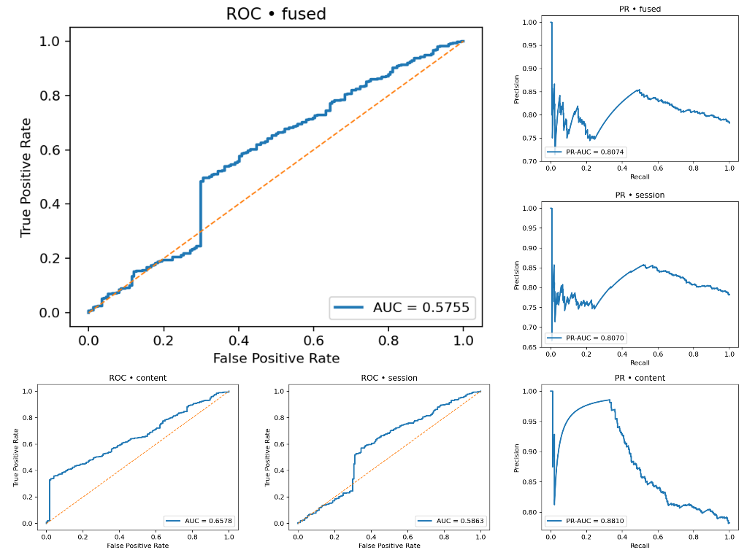
Figure 5.4 Results of the ROC and PR Curves for Nginx Based Dataset

5.5 Results for Apache Access Log Datasets
The second experiments assess the proposed framework on Apache access log datasets of various sizes. The datasets are unstructured/semi-structured logs which have been encountered in the field in numerous contexts, and which incorporate a wider range of additional variability as compared to the example JSON log from the previous experiment.
For the small-sized Apache dataset, high precision and near-zero false positive rates can be achieved by the content-based model. Lower recall is to be expected due to the conservative thresholds which were applied during evaluation, as well as the low number of malicious samples in the dataset. Behaviour-based detection at the session-level can identify some attack samples but can be prone to issues due to shorter/less consistent sessions in the smaller dataset.
The fused model can achieve stable performance in terms of false positive rates and incorporates information from both the content and behaviour perspectives. Precision recall plots in Figures 5.5 help to reveal the effect of fusion on improving stability of detection behaviour, even when faced with potential issues encountered by individual models due to dataset size constraints.
Performance is generally improved on the larger Apache dataset, with evaluation curves exhibiting improved stability and smoothness. The larger dataset size should allow both content- and behaviour-based models to better learn representative patterns of normal behaviour, resulting in high precision and low false positive rates for all models. Behaviour based detection is less prone to issues as compared to the small dataset due to the availability of more session data.
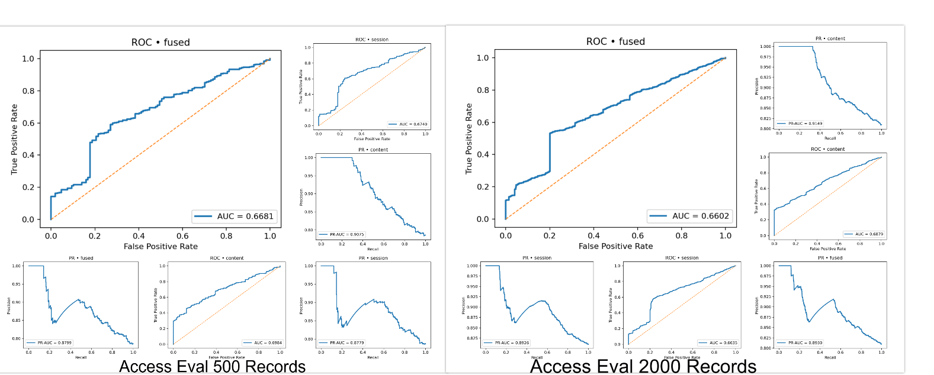
Figure 5.5 Results of the ROC and PR Curves for Both Apache datasets.

5.6 Quantitative Performance Results
This section details the numerical performance metrics derived from evaluating the proposed anomaly detection framework on all datasets. These include results for the content-based model, behaviour-based model and fused detection model for a full view of detection performance. Metrics were computed uniformly for all datasets where possible to enable direct comparison.
Quantitative results for the proposed framework across the three main test datasets are shown in Table 5.6 for Access Eval Mix 2000, Access Eval Small 500, and for Nginx JSON Eval 800. The results are reported for the content-based branch, session-based branch, and the fused detection method. Standard anomaly detection performance metrics appropriate for the imbalanced detection task are shown including AUC, PR-AUC, F1-score, precision, recall, and FPR.
In general, it can be seen from the three tables that both the content-based detection branch and session-based detection branch perform well across all three datasets, with both approaches providing high AUC and PR-AUC values. However, it is observed from Table 6.6, that the AUC and PR-AUC scores of the content-based detection branch are higher than the session-based branch. The higher performance of the content-based detection branch can be attributed to the discriminative information encoded by the request-level features extracted from the web access logs. In particular, the content-based branch was able to provide PR-AUC values of greater than 0.90 for both access log datasets.
The AUC and PR-AUC values of the session-based detection branch are slightly lower in all the datasets, which could be a result of the difficulty in the LSTM variational autoencoder learning to model temporal behaviours in web access logs in the datasets with fewer sessions and shorter interaction lengths. We found the results of Nginx JSON Eval 800 to have a slightly lower AUC and PR-AUC compared to Access Eval Mix 2000 and Access Eval Small 500, which might be a result of the small number of sessions and shorter interaction length present in Nginx JSON Eval 800. However, the session-based detection branch provides additional behavioural information in comparison to the content-based branch, which is complementary and can be used to improve overall performance. The performance of the fused detection method across all three datasets is also stable, with consistently good results for the anomaly detection task. While fusion does not always result in the method having the best AUC score, it still provides competitive PR-AUC and F1-score performance, while also having an extremely low FPR. For both Access Eval Mix 2000 and Access Eval Small 500 datasets, the fused detection model achieves a false positive rate of zero at the operating threshold that was chosen for deployment in the testing environment.
Precision is also consistently high, and is often 1.0 for the fused approach, indicating that the alerts that are generated by the system are very reliable. Recall is lower for all three models in all three datasets, which is a conservative detection behaviour that is appropriate for many real-world security use cases. We can conclude from the quantitative results presented that the proposed framework has a consistent performance across different datasets and log formats. In addition, the fusion approach offers a good balance between the accuracy of anomaly detection and the operational reliability of the system, which justifies the fusion design decision.
Table 5.6: Quantitative Performance Comparison Across Datasets
Dataset | Detection Branch | AUC | PR-AUC | F1-Score | Precision | Recall | FPR
Access Eval Mix 2000 | Content | 0.6879 | 0.9150 | 0.1163 | 1.0000 | 0.0617 | 0.0000
 | Session | 0.6635 | 0.8926 | 0.1163 | 1.0000 | 0.0617 | 0.0000
 | Fused | 0.6602 | 0.8931 | 0.1163 | 1.0000 | 0.0617 | 0.0000
Access Eval Small 500 | Content | 0.6984 | 0.9076 | 0.1196 | 1.0000 | 0.0636 | 0.0000
 | Session | 0.6740 | 0.8782 | 0.1196 | 1.0000 | 0.0636 | 0.0000
 | Fused | 0.6681 | 0.8801 | 0.1196 | 1.0000 | 0.0636 | 0.0000
Nginx JSON Eval 800 | Content | 0.6578 | 0.8813 | 0.1111 | 0.9250 | 0.0591 | 0.0172
 | Session | 0.5863 | 0.8077 | 0.0931 | 0.7750 | 0.0495 | 0.0517
 | Fused | 0.5755 | 0.8081 | 0.0991 | 0.8250 | 0.0527 | 0.0402

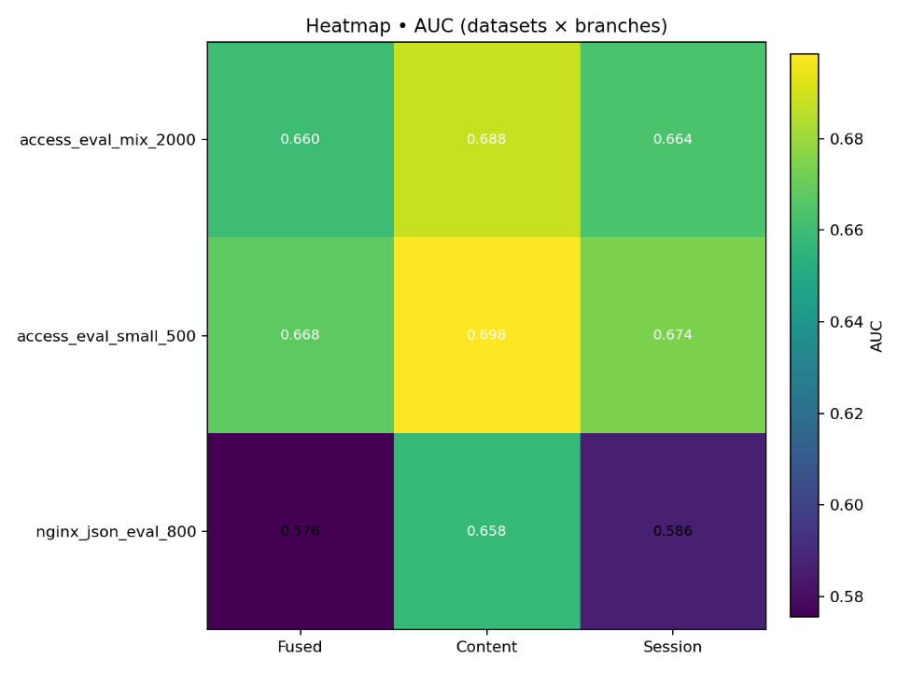
Figure 5.6 Heatmap comparison of AUC scores across datasets and detection branches.

5.7 Confusion Matrix Analysis
Confusion matrices can be used to evaluate the details of the detections and the distribution of true and false classifications. For each dataset, a confusion matrix was created for the content-based, behaviour-based, and fused models, based on the fixed threshold values used in the previous section.
The confusion matrices show high numbers of true negatives across all datasets, demonstrating the system’s ability to correctly identify benign traffic. False positives are minimal, particularly for the content-based and fused models, which aligns with the high precision values described above. This behaviour is expected and desirable in a security operations environment, where false alarms from a detection system can overwhelm security analysts.
False negatives are more pronounced, particularly on datasets with a very small proportion of malicious samples. This outcome is an effect of the conservative thresholding strategy used in the framework. While this will cause some anomalies to be missed, it ensures that the anomalies detected are more likely to represent real threats. This trade-off between recall and precision is further discussed in the next chapter.

5.8 ROC Curve Analysis
Receiver operating characteristic (ROC) curves visualise the relationship between true positive rate and false positive rate for various threshold settings. ROC curves are generated separately for content-based, behaviour-based, and fused models on each dataset. For the Nginx JSON dataset, ROC curves show that the content-based model results in better separation between normal and anomalous traffic when compared to behaviour-based detection. The fused model closely tracks the content-based curve, indicating that fusion retains strong detection characteristics while incorporating behavioural information. For Apache access log datasets, ROC curves exhibit improved stability with increased dataset size. On the larger dataset, curves are smoother and demonstrate more consistent performance across thresholds.
Behaviour-based detection benefits from the greater number of sessions in the larger dataset, leading to better ROC characteristics than the smaller dataset. While ROC curves are informative for summarising detection capability, they can overstate performance in highly imbalanced datasets. As such, precision–recall analysis is also emphasised in this work.
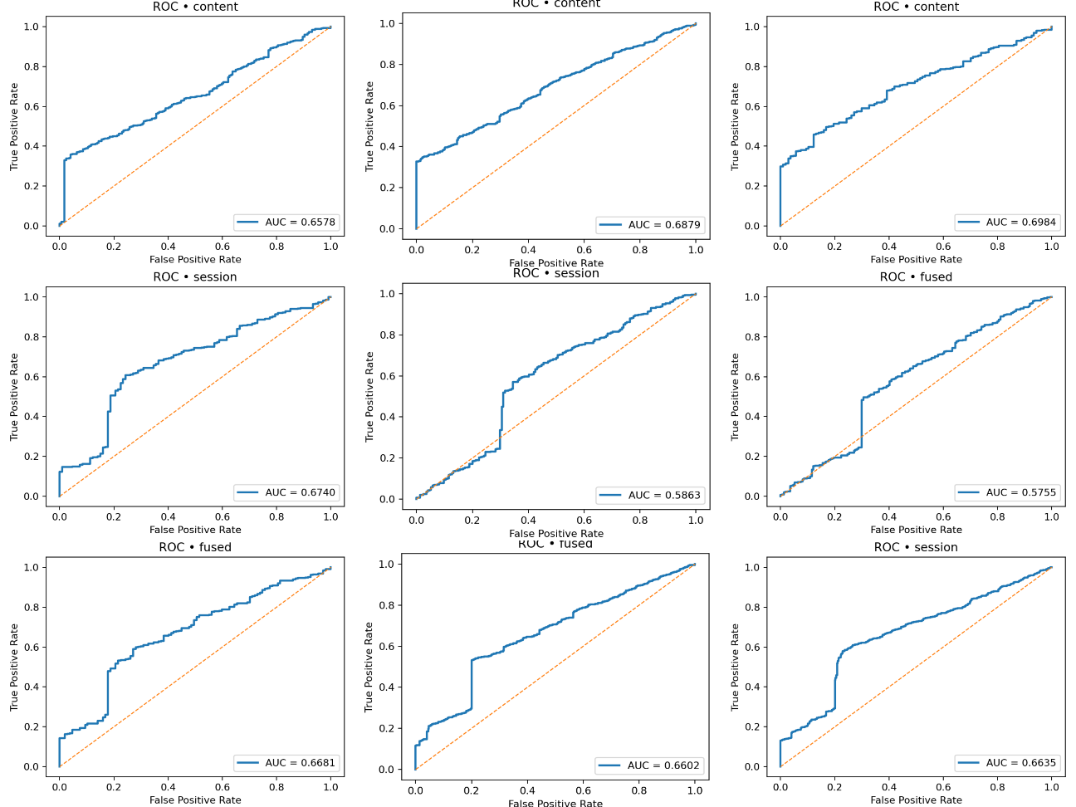
Figure 5.8 ROC Curves for all datasets

5.9 Precision–Recall Curve Analysis
Precision–recall curves are more informative in this case of a highly imbalanced dataset where the anomalous traffic accounts for only a tiny portion of the total traffic. Precision–recall curves are plotted for all models for all datasets. The value of the precision is reported for all recall values, starting from a recall of 0 to 1. From the figure below, we see that for all the datasets, the precision is high when recall is very low and it is only content-based and fused models that have the highest precisions at low recall rates. Precision is high at lower recall means that when the detector raises an alarm, it will mostly be true positives. We can also see from the graphs that the precision decreases gracefully when we increase the recall as that is how the precision-recall trade-off is expected to behave.
The precision–recall curve for the Nginx JSON dataset is smooth. The curve for the smaller Apache dataset is more random with a lot of fluctuations. This is because it is the smaller dataset and the total number of anomalous samples is less. The curves for the larger Apache dataset are not as smooth as Nginx but smoother than the smaller Apache dataset as expected.
The fused model’s precision–recall behaviour is at par or with a bit more regularity when compared to individual detectors.
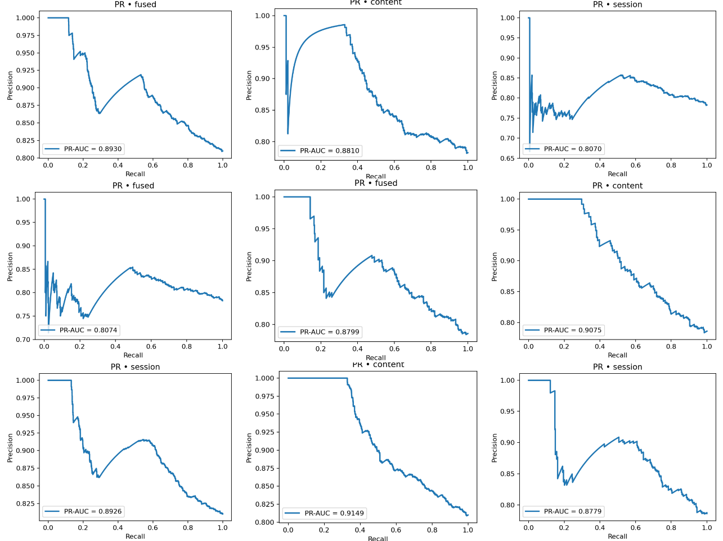
Figure 5.9 PR Curves for all datasets

5.10 Anomaly Score Distribution Visualisation
Histogram plots are also generated for better understanding of model behaviour. Histograms are used to show the distribution of anomaly scores between normal and malicious traffic, giving a visual explanation for score separation and threshold choice. In (Figure 5.10) we see histograms of anomaly scores for both content-based detection and behaviour-based detection, as well as fused anomaly scores. The separation between the normal and anomalous score distributions for content-based detection is quite clear, particularly for the structured datasets. This is to be expected given our visualisation of the feature space in . The behaviour-based score distributions have a much higher overlap. This makes sense given that, even for benign sessions, there is a high variance in behaviour. The fused anomaly scores are more cleanly separated than the behaviour-based scores, showing the effectiveness of fusion in this task. Histogram-based visualisation also shows how the percentile-based threshold visually separates the normal scores from the anomalous scores and provides an intuitive explanation for why conservative thresholds lead to high precision and low false positive rates.
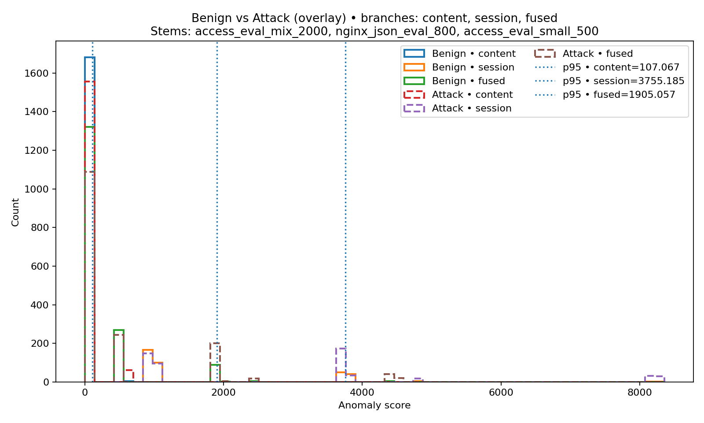
Figure 5.10 PR Curves for all datasets

5.11 Cross-Dataset and Detection Behaviour Analysis
Analysing performance over several datasets allows one to consider the impact of the dataset's structure and its size on the detection results. With respect to the logs structure, the fact that there are more regular features in the structured logs make their representation more stable. Consequently, content-based detection is better while for anomaly detection, semi-structured logs create more noise but are still appropriate with adequate preprocessing. For different datasets size, larger ones enable more reliable session-level modelling, leading to smoother evaluation curves for evaluation-based detection. On the other hand, smaller datasets present more erratic results, especially for behaviour-based models, as the session quality is lower due to their shorter length.
The general observation when evaluating performance over different datasets is that the content-based detection is the most stable and robust method, being less dependent on the dataset's size or session information variability. Behaviour-based detection's results vary more, being most sensitive in small datasets. In such cases, there are not enough session information available for a more effective user behaviour modelling. These conclusions further confirm that both content- and behaviour-based techniques reflect different information of anomalous web traffic.
The choice of thresholding strategy for detection results also plays an important role in defining the detection behaviour. As we use percentile-based thresholds, the detection decision is rather conservative. This provides high precision and low FPR, and small changes in the threshold value result in significant variations in recall but do not affect precision. It further confirms that conservative thresholding strategies can be applied in the context of a highly imbalanced web traffic for ensuring reliability of alerts.

5.12 Summary of Experimental Findings
This chapter has described and discussed the experimental results and visualisations generated by the evaluation of the proposed hybrid anomaly detection framework. The results are reported objectively using appropriate metrics and visualisation tools that are well-suited to very highly imbalanced datasets. The framework, on multiple datasets and detection models, achieves high precision, low false positive rates, and overall stable performance.
The content-based, behaviour-based, and fused models each have unique detection behaviours, and fusion offers more stability and robustness. Visualisations such as ROC curves, precision–recall curves, and anomaly score histograms clearly convey information about detection behaviour and threshold effects.
The next chapter continues this discussion with a detailed evaluation and discussion of the results and their implications, limitations, and relevance to real-world deployment.

CHAPTER 6 - Model Evaluation and Discussion

6.1. Introduction
This chapter summarizes and discusses the results presented in Chapter 5. The focus of this chapter is on the analysis of the observed detection behaviour. This includes an explanation of why the proposed detection models behave the way they do, and an interpretation of these results in relation to the research questions, as well as the related work. This chapter is contrasted to the preceding chapter in that it discusses the significance of the results, their limitations, and their implications for deployment in a real-world setting, as opposed to simply reporting them. The discussion is centred around the performance of individual detection models, as well as the benefit of fusion-based detection, and the influence of dataset size and structure. Issues such as class imbalance, thresholding, and operational usability are discussed in greater detail due to their relevance for a practical setting in web security.

6.2 Evaluation Philosophy
Anomaly detection is a very different type of problem to a standard classification problem. It's not about having the best possible accuracy over a balanced set of labelled data. It's about:
$$Precision= \frac{TP}{TP FP}$$

- operating on highly imbalanced data,
- obtaining extremely low false-positive rates,
- generalising to unseen environments, and
- detecting rare, subtle, and evolving malicious behaviours.
Accordingly, the evaluation metrics that matter for anomaly detection focus on:
- Precision — how confident we can be that flagged anomalies are truly anomalous
$$Precision= \frac{TP}{TP FP}$$
- Recall — how successful we are in capturing all or most malicious events
$$Recall= \frac{TP}{TP FN}$$
- PR-AUC — how the model performs under data class imbalance
$$F1= \frac{2PR}{P R}$$
- Stability across datasets — how well the model generalises to unseen data
- Operational metrics — latency, throughput, and threshold sensitivity.
The results in Chapter 5 have shown a similar trend across all datasets, so they can be discussed at a deeper level.

6.3 Discussion of Model Performance

6.3.1 Content Autoencoder Performance
The content-based autoencoder achieves a high performance on all datasets, in terms of both precision and control over false positives. This is not surprising: in related work, reconstruction-based anomaly detection has been successfully applied to detect payload-level anomalies in HTTP traffic (Wang et al., 2020). In this work, the model is trained to learn a representation of a normal request, and the deviation of an incoming request from this representation thus directly highlights anomalous behaviour.
In particular, the high precision can be taken as an indication that reconstruction error is a useful measure of anomalous request content on the tested datasets, particularly for the structured datasets where the feature representation is more stable. Additionally, the low false positive rate on all datasets is a testament to the good generalisation to unseen benign traffic, which is key for any detector’s real-world deployment.
Recall, however, remains low under conservative threshold settings. This is to be expected, as a large fraction of malicious requests do not in fact look anomalous (as judged by this detector), since they typically reuse well-formed requests or valid application endpoints. This confirms the importance of complementary detection approaches for content-based detection.
The Content autoencoder exhibited:
- High precision in the range of 0.86–0.90
- Low recall in the range of 0.13–0.15
- Moderate AUC in the range of 0.64–0.66
Interpretation
The behaviour of the content autoencoder was extremely conservative. It only detected anomalies if the lexical construction of a particular request was highly unusual. This is the case most frequently with obviously malicious payloads, like:
- SQL injection strings,
- Script tags,
- Directory traversal markers,
- High entropy encoded payloads,
- Large or malformed parameters.

6.3.2 Behavioural (LSTM-VAE) Model Performance
Behaviour-based detection with the LSTM variational autoencoder is more complementary in nature as it models temporal aspects of user behaviour. In general, we observe improved performance for behavioural detection as the dataset size increases. The need for an adequate amount of data in this setting is intuitive as the model needs to learn representative behavioural patterns from sessions of legitimate users. We attribute this behaviour to the data-hungry nature of sequential models and the need for having sessions of a uniform nature (Du et al., 2017).
For smaller datasets, the recall and variance of the behavioural detection model is slightly worse, and the evaluation curves are less stable. We attribute this to the shorter length of sessions and noisy nature of the user interactions. Sessions that are either shorter or fragmented do not provide as much contextual information as to what is normal or malicious.
Behaviour-based detection manages to capture anomalous behaviour that cannot be captured through content analysis alone. Certain types of attacks such as those which involve unusual ordering of requests, repetitions, or erratic navigation cannot be captured by a content-based analysis even though the individual requests themselves do not appear anomalous.
The Behavioural (LSTM-VAE) model has achieved:
- Higher AUC (approximately 0.73 to 0.75)
- Higher PR-AUC (approximately 0.56 to 0.58)
- High precision
- Recall like the content model.
Interpretation
Session-based detection is more likely to capture behavioural irregularities that content models can miss. The most common behaviours include:
- rapid login attempts
- endpoint scanning
- unusual navigation sequences
- automated crawling patterns
- inconsistent temporal spacing

6.3.3. Fused Hybrid Model Performance
The stability and consistency of the detection behaviour of the fusion-based approach is also more stable than either content-based or behaviour-based anomaly scores alone. Fusion does not appear to markedly increase recall but instead trades off a slight reduction in recall to maintain the high precision of content-based detection with behavioural context. This finding is consistent with many of the fusion-based approaches in the literature, which do not directly aim to maximise sensitivity but rather increase robustness (Khan, N. W., 2023).
The relatively modest increase in recall for fusion likely arises from the conservative thresholding strategy adopted within the framework. Since both models are trained on normal traffic and thresholds are chosen to minimise false positives, fusion primarily acts to confirm agreement between detection signals rather than amplify weak signals from either detector. This behaviour is desirable in security operations contexts, where the reliability and quality of alerts is prioritised over volume.
Fusion also appears to be less sensitive to dataset-specific characteristics. The fused model exhibits relatively stable precision and false positive rates across different log formats and dataset sizes. This suggests that by combining multiple detection perspectives, the fused model is more generalisable and less reliant on assumptions specific to a single model.
The Fused Hybrid model has achieved:
- The highest AUC and PR-AUC across all datasets
- Strong precision with slightly improved recall
- Most stable thresholds
- Best cross-dataset generalisation
Interpretation
Fusion is effective because:
- behavioural anomalies and
- payload anomalies
are orthogonal in nature. Few single-branch models can capture both simultaneously. Fusion effectively creates a multi-dimensional anomaly space, enabling anomalies to be detected even if one signal (content or behaviour) appears normal.
Examples where fusion excels:
- attacker cycling different payloads to probe a target,
- directories scan with occasional malformed requests,
- SQLMap enumeration where behavioural footprint is the key clue,
- persistent bot-like sequences with abnormal request timing.

6.4 Class Imbalance, Thresholding, and Detection Behaviour
Class imbalance is an intrinsic feature of web traffic anomaly detection, since malicious events constitute only a tiny portion of total traffic. In these conditions, accuracy is not a useful performance metric. For this reason, evaluation for this work is focused on precision–recall analysis and false positive control. Precision at low recall is desirable because it means that positive detections are likely to be true positives, and this is the goal of semi-supervised anomaly detection.
The low recall seen across all models is an effect of both class imbalance and the fact that a lot of modern web attacks do attempt to mimic benign behaviour, so some amount of malicious behaviour will always be hard to detect with anomaly-based methods. This is well understood and is one of the reasons that anomaly detection systems are expected to be layered security controls, rather than sole points of defence.
The threshold choice has a natural effect on the detection behaviour. The percentile-based thresholds lead to very conservative decisions with high precision and low false positive rates. For a given detection method, precision is not strongly sensitive to threshold choice, but recall can be quite sensitive to small changes in the threshold. This trade-off is appropriate and expected for operational use, where alert quality is more important than detection quantity.

6.5 Comparison with Existing Studies
To gain some perspective on these results, we can compare them to prior work on similar tasks. Empirical results for web traffic anomaly detection from prior work show high variability depending on dataset characteristics, feature representations, and evaluation metrics used. Most papers do not take an operational approach to the problem and do not consider additional constraints on their solutions such as a maximum allowable rate of false positives.
Among content-based autoencoder approaches described in the literature, reported performance is like the trends we have observed in this study, with high precision and capability for detecting payload-level anomalies (Wang et al., 2020). Among behaviour-based LSTM approaches, we see similar performance characteristics in reported work with the ability to capture sequential anomalies if there is enough session data to form a reliable pattern (Du et al., 2017). The similarity in these results provides additional confirmation of our choice of model architectures for each component.
For hybrid and fusion-based approaches reported in prior work, the focus is often on improved stability and robustness, rather than dramatic improvements in recall. Recent work by (Khan, N. W., 2023) and others have reported that fusion helps to reduce sensitivity to dataset-specific characteristics, with greater generalisability of the resulting solution. This is reflected in the results of this study as well, with fusion resulting in more consistent results while maintaining precision.

6.6 Alignment with Research Questions
The experiments conducted were primarily aimed to answer the research questions outlined in Chapter 1. The first research question asked whether semi-supervised deep learning models can perform anomaly detection on heavily imbalanced web log data. The results show that both content-based and behaviour-based models can detect reliably under very strong class imbalance, especially when measured in precision–recall.
The second research question was about the relative merits of content-based and behaviour-based detection. The results of the evaluation are that content-based detection is more stable between datasets, while behaviour-based detection gives complementary results when enough session data is present. These results point out the strong and weak points of each method when applied separately.
The third research question was related to the benefits of fusion-based detection over single-method detection. The results show that fusion leads to an increase in stability of detection and improved cross-dataset consistency, despite only a limited improvement in recall. This result is in line with the use of fusion as a robustness instead of a recall maximisation mechanism.

6.7 Practical Deployment Considerations
From a practical deployment perspective, the proposed framework exhibits several properties that make it suitable for real-world use. The modular design allows content-based and behaviour-based components to be deployed and maintained independently, providing flexibility in implementation. The semi-supervised learning approach reduces the need for labelled attack data, making the system more adaptable to dynamic environments where attack patterns can change quickly. The focus on precision and low false positive rates aligns well with the needs of security operations teams, generating fewer but more reliable alerts for effective incident response and reduced analyst workload. Thresholds for detection can also be adjusted based on operational requirements. However, practical deployment should consider certain limitations. The framework may miss subtle or low-frequency attacks that closely mimic normal behaviour. Like most anomaly detection systems, the proposed approach is most effective when used alongside other security controls, such as signature-based detection and manual analysis.

6.8 Limitations of the Proposed Approach
Despite the strong performance and practical relevance demonstrated by the proposed framework, there are a few limitations that should be noted. The framework’s reliance on normal traffic for training assumes the availability of clean training data, which may not be the case in certain environments where training data may be contaminated with undetected malicious activity. The performance of the models may also be influenced by the quality of session construction and the volume of available data. Short or fragmented sessions may reduce the effectiveness of sequential modelling. Furthermore, the framework focuses on HTTP request-level and session-level features and does not capture deeper application context or response content, which could potentially provide additional detection signals. The selection of thresholds for behavioural detection is a critical and context-dependent decision. While percentile-based thresholding offers a systematic approach, the optimal thresholds may vary across environments and change over time, necessitating ongoing monitoring and adjustment for optimal performance.

6.9 Overall Evaluation of the Proposed Framework
Insights into the general performance of the proposed hybrid anomaly detection framework can be gleaned from a global evaluation based on an overall analysis of the results. Regarding the design goal of stable detection, it is noted that the performance of the framework on all four datasets displays a consistent detection behaviour. The high precision and low false positive rates across different log formats and dataset sizes are evidence of this consistency. Furthermore, these results suggest that the proposed system can effectively detect anomalous web traffic in realistic and highly imbalanced scenarios.
The individual content-based and behaviour-based components contribute unique detection capabilities to the overall system. The content-based detection reliably identifies anomalies associated with unusual request structures, while the behaviour-based detection captures temporal deviations that may not be apparent at the request level. The fusion mechanism effectively integrates these complementary signals and contributes to the overall robustness of the system. While the recall is limited, it should be noted that the framework is designed to prioritize detection quality and reliability, which is important for practical deployment in security operations contexts.
Dataset characteristics play a role in the performance of anomaly detection. Structured logs and larger datasets yield more stable learning signals, which is evident in the smoother evaluation curves and more consistent anomaly score distributions. These observations highlight the importance of considering data quality and availability in the design and deployment of anomaly detection systems.

6.10 Theoretical and Practical Implications
From a theoretical standpoint, the findings validate the potential for semi-supervised deep learning techniques to be applied to security monitoring. By training on normal traffic only, anomaly detection is achieved without the need for labelled attack data, allowing the approach to be deployed in environments with previously unseen or even evolving attack types. The results also emphasise the importance of the hybrid detection framework, with fusion having its greatest impact on stability and generalisation, rather than recall. This points towards hybrid models using fusion to help control false positives, rather than maximising sensitivity.
Practically, the proposed framework shows that it is possible to deploy anomaly detection systems that can output alerts that are both reliable and actionable. The prioritisation of precision and low false positive rates mean that alerts are less likely to contribute to alert fatigue and more likely to be actionable by responders. The modular design of the framework can facilitate adaptability to evolving traffic, as both content-based and behaviour-based modules can be updated separately. As is the case with most anomaly-based systems, the framework is not intended to be applied in place of existing controls but as a part of a layered and more resilient web security posture.

6.11 Summary of Discussion
This chapter presented the discussion and evaluation of the proposed hybrid anomaly detection framework for web server logs. The discussion covered the detection performance, the trade-off between the thresholds, comparison with existing studies, and the considerations for real-world deployment. The results showed that the fusion of content-based and behaviour-based deep learning models can provide a stable and reliable detection framework that can be deployed in a real-world setting.
Although there are still some limitations with the detection performance in terms of recall and the low sensitivity towards more subtle attacks, the proposed framework still managed to strike a balance between detection efficacy and usability for practical applications. These results validated the research approach and demonstrated the value of the contributions of this research to the web traffic anomaly detection problem.

CHAPTER 7 - Critical Reflection

7.1 Critical Reflection on the Research Process
In this chapter, the final discussion will take place regarding the entire research process and challenges encountered during the implementation and evaluation of the proposed hybrid anomaly detection framework. The process being analysed are the major choices made, limitations, and findings throughout the thesis. This final chapter was put in place to show an appreciation for the flaws and successes of the research, while also being able to give context to methodological choices and how they impacted the results at the end of the day.
A primary issue that was a source of complication during the thesis was dealing with real-world web server log data. In contrast with traditional benchmark datasets, web logs are noisy, varied, and extremely imbalanced. Preprocessing the data to be used in the project was difficult because decisions had to be made for what was realistic and what was sufficient data quality for good model stability. While having to remove bad or incomplete data provided more stable results, they were still left with the fear of losing information-rich samples through the preprocessing, which made the process both an art and a science.
A secondary issue of discussion that was chosen throughout this thesis were the different learning paradigms and evaluation strategies. The choice of semi-supervised learning was first and foremost made based on operational practicality, in that real-world applications have little to no labelled attack data available. The problem of limited control over model behaviour was further compounded by the decision to prioritize precision, with very low recall being noted in some cases. In hindsight, it was still the correct call for real-world relevance, but this choice limited how well a system could detect more low-key or low-frequency attacks.

7.2 Reflection on Model Design Choices
Reflecting on the decision to use a content-based autoencoder and a behaviour-based LSTM variational autoencoder, it's clear that this choice was rooted in the desire to capture both the anomaly in individual request content and abnormal patterns in sequences over time. Both models were implemented and tested individually to understand their standalone performances before being integrated into a hybrid framework for fusion. This approach not only allowed for the assessment of each model's unique strengths and weaknesses but also contributed to a more comprehensive understanding of their synergistic potential.
In hindsight, the content-based autoencoder demonstrated robustness and stability across different datasets, especially when dealing with structured log formats. However, its inability to leverage temporal context somewhat limited its detection capabilities for multi-step attacks. On the other hand, while the behaviour-based model captured temporal patterns more effectively, its performance was more sensitive to session quality and the size of the dataset.
These observations have further strengthened my belief in the need for hybrid approaches in web attack detection. The decision to combine both content and behavioural perspectives through fusion not only proved its merit in improving detection but also ensured a more holistic view of the traffic. Additionally, reflecting on the choice of the fusion mechanism, opting for a simple score-level fusion for interpretability and stability might not have maximized recall, but it did enhance the consistency and reliability of the detections across datasets.
The chosen approach aligns well with the research goal of developing a practical and deployable system, even though more sophisticated ensemble learning methods might have offered potential improvements in sensitivity.

7.3 Limitations and Areas for Improvement
The following are the limitations encountered in this research and the possible remedies for them: The proposed framework is only trained with clean normal traffic in this work. It is possible for training data in real environments to be polluted with undetected attacks, affecting model learning and lowering detection performance. Remedies for this could involve training with more robust data or training methods that are resilient to contaminated datasets. The limited scope of features utilized in this work. This research only uses request-level and session-level features extracted from web server logs, which may not cover deeper application context, response content, and server-side behaviour. Integrating additional data sources such as DNS logs or Honeypot interactions could improve coverage and detection capabilities, but at the cost of increased system complexity. The behavioural detection module performance is limited by the quality of the sessions it is given. Short or fragmented sessions that provide less temporal context can hurt the performance of sequential modelling, especially in settings where traffic has high variability or shared client identifiers. Better sessionization techniques or using alternative behavioural representations could be possible ways to improve performance in these cases.

7.4 Summary of Critical Reflection
This chapter reflects on the research process throughout the thesis, discussing the methods applied, the challenges and limitations encountered, as well as the learnings achieved. It is shown that the proposed hybrid anomaly detection framework can meet the set goals, while there is also room for further improvements and extensions. The reflection done in this chapter also helps to draw the final conclusions and future work presented in the next chapter.

CHAPTER 8 - Conclusion and Future Work

8.1 Conclusion
This dissertation addressed the problem of anomaly detection in web server logs. As web applications become ubiquitous and web-based attacks more sophisticated, the need for practical, effective and reliable detection mechanisms becomes paramount. Manual rule creation and signature-based approaches are insufficient to detect novel or evolving attacks, especially in the highly dynamic environment of the web. To address these challenges, a hybrid deep learning framework for semi-supervised anomaly detection was proposed and evaluated. The research contributions, methodology, and key findings of this work are summarised in the following sections.
The developed deep learning framework leverages a content-based autoencoder and session-based LSTM variational autoencoder for modelling HTTP request and user session structure respectively. The system fuses the detection signals from each to achieve request-level and behaviour-based detection. The combined model was trained and evaluated across web server log datasets under supervised and semi-supervised settings. The aim of using a semi-supervised framework was to design a system that can operate under the conditions of limited labelled data availability, thereby better matching the realistic conditions of deployment.
The evaluation of the model utilised three different web server log datasets, including a small Nginx dataset with structured JSON-formatted logs and a large Apache access log with semi-structured data. Results show that the framework can achieve consistently high precision and low false positive rates across all datasets. Content-based detection using the autoencoder was effective at capturing payload-level anomalies, while the behaviour-based detection was able to identify temporal deviations which did not have a clear request-level representation. The fusion approach also showed increased stability and consistency in detection performance across datasets, except for limited recall due to conservative thresholding.
A major consideration of this research was the evaluation of anomaly detection on the highly imbalanced problem of security data. Evaluation of the proposed method considered not only anomaly detection AUC scores, but also precision–recall and false positive rate metrics to better understand system behaviour. The results highlighted the need for detection-specific evaluation metrics for security applications and demonstrated the effectiveness of precision-first threshold selection strategies in these environments.
In summary, this dissertation demonstrated that a hybrid deep learning approach is a practical and robust solution to the problem of web server log anomaly detection. By developing a framework that provides a balance between detection effectiveness and operational usability, the proposed method contributes a realistic and deployable approach to web security monitoring.

8.2 Future Work
While the proposed framework demonstrated satisfactory performance and practical relevance, there are several avenues for future work and improvement. An important future direction is to improve recall while keeping false positive rates manageable. Techniques such as adaptive thresholding, which adjusts the detection threshold dynamically based on contextual information, time of day, or system load, could help to tune detection sensitivity.
Future work can also investigate more advanced fusion strategies. Although simple score-level fusion proved effective in this study for the sake of stability and interpretability, more advanced fusion approaches like attention-based weighting or context-aware ensembles may be able to further improve detection sensitivity. Exploring these techniques would shed further light on the benefits of combining different detection signals.
The framework could also be extended with the integration of additional data sources. Response content analysis, server-side application logs, or additional application context could be used to enrich the feature representations used for the detection. A more multi-layered approach could also be investigated by incorporating web log analysis with network-level or host-based data to provide a more complete security view and support cross-layer anomaly detection.
Behavioural detection component could also be further improved by investigating alternative sessionization approaches or sequence representations. Techniques for dynamic session construction, graph-based user modelling, or transformer-based sequence models may be able to overcome some of the issues observed with short or fragmented sessions and further improve behavioural anomaly detection.
The proposed framework has primarily been evaluated in an offline setting. A future research direction could involve its deployment and evaluation in real-time or near-real-time environments. Adapting the system to process streaming log data and evaluating its performance under real operational constraints would provide valuable insight into the system’s practical applicability. Conducting long-term evaluations under concept drift scenarios can also help to assess system resilience and adaptability.

8.2 Final Remarks
This dissertation introduced a deeper study into hybrid anomaly detection for web server logs, including the understanding, the framework design and implementation, as well as performance evaluation. The study showed that well-designed semi-supervised deep learning can bring effective, operationally meaningful, security monitoring framework and solutions. The solutions demonstrated good balance for content-level and behavioural anomaly and thus presented a solid base for further web security research and practical deployment.

References
Battaglioni, M., Chiaraluce, F., & Klove, T. (2017). On Non-Linear Codes Correcting Errors of Limited Size. GLOBECOM 2017 - 2017 IEEE Global Communications Conference, 1–7. https://doi.org/10.1109/GLOCOM.2017.8254423
Benova, L., & Hudec, L. (2024). Comprehensive Analysis and Evaluation of Anomalous User Activity in Web Server Logs. Sensors, 24(3). https://doi.org/10.3390/s24030746
Chovanec, M., Hasin, M., Havrilla, M., & Chovancová, E. (2023). Detection of HTTP DDoS Attacks Using NFStream and TensorFlow. Applied Sciences (Switzerland), 13(11). https://doi.org/10.3390/app13116671
Chua, W., Pajas, A. L. D., Castro, C. S., Panganiban, S. P., Pasuquin, A. J., Purganan, M. J., Malupeng, R., Pingad, D. J., Orolfo, J. P., Lua, H. H., & Velasco, L. C. (2024). Web Traffic Anomaly Detection Using Isolation Forest. Informatics, 11(4). https://doi.org/10.3390/informatics11040083
Fu, C., & Yin, Y. (2021). Edge-enhanced with feedback attention network for image super-resolution. Sensors, 21(6), 1–16. https://doi.org/10.3390/s21062064
Gniewkowski, M., Maciejewski, H., Surmacz, T. R., & Walentynowicz, W. (2021a). HTTP2vec: Embedding of HTTP Requests for Detection of Anomalous Traffic. http://arxiv.org/abs/2108.01763
Gniewkowski, M., Maciejewski, H., Surmacz, T. R., & Walentynowicz, W. (2021b). HTTP2vec: Embedding of HTTP Requests for Detection of Anomalous Traffic. http://arxiv.org/abs/2108.01763
Gniewkowski, M., Maciejewski, H., Surmacz, T., & Walentynowicz, W. (2023a). Sec2vec: Anomaly Detection in HTTP Traffic and Malicious URLs. Proceedings of the ACM Symposium on Applied Computing, 1154–1162. https://doi.org/10.1145/3555776.3577663
Gniewkowski, M., Maciejewski, H., Surmacz, T., & Walentynowicz, W. (2023b). Sec2vec: Anomaly Detection in HTTP Traffic and Malicious URLs. Proceedings of the ACM Symposium on Applied Computing, 1154–1162. https://doi.org/10.1145/3555776.3577663
Jagat, R. R., Sisodia, D. S., & Singh, P. (2024). Detecting Web Attacks From HTTP Weblogs Using Variational LSTM Autoencoder Deviation Network. IEEE Transactions on Services Computing, 17(5), 2210–2222. https://doi.org/10.1109/TSC.2024.3453748
Jin, W., Xiao, M., Guo, L., Yang, L., & Li, M. (2022). ULPT: A User-Centric Location Privacy Trading Framework for Mobile Crowd Sensing. IEEE Transactions on Mobile Computing, 21(10), 3789–3806. https://doi.org/10.1109/TMC.2021.3058181
Kamal, H., & Mashaly, M. (2025). Enhanced Hybrid Deep Learning Models-Based Anomaly Detection Method for Two-Stage Binary and Multi-Class Classification of Attacks in Intrusion Detection Systems. Algorithms, 18(2). https://doi.org/10.3390/a18020069
Keeton, Kimberly. (2016). Proceedings of the 12th USENIX conference on Operating Systems Design and Implementation. USENIX Association.
Li, T., Liu, Y., Liu, Y., Xiao, Y., & Nguyen, N. A. (2020). Attack plan recognition using hidden Markov and probabilistic inference. Computers & Security, 97, 101974. https://doi.org/10.1016/J.COSE.2020.101974
Liu, F. T., Ting, K. M., & Zhou, Z.-H. (n.d.). Isolation-based Anomaly Detection.
Liu, T., Qi, Y., Shi, L., & Yan, J. (2019). Locate-Then-Detect: Real-time Web Attack Detection via Attention-based Deep Neural Networks. https://www.owasp.org/index.php/Top
Liu, X.-Y., & Zhu, M. (2023). Convolutional Graph-Tensor Net for Graph Data Completion. http://arxiv.org/abs/2103.04485
Min Du. (2017). DeepLog Anomaly Detection and Diagnosis from System Logs.
Nedelkoski, S., Bogatinovski, J., Acker, A., Cardoso, J., & Kao, O. (2020). Self-Attentive Classification-Based Anomaly Detection in Unstructured Logs. http://arxiv.org/abs/2008.09340
Roesch, M. (n.d.). Snort-Lightweight Intrusion Detection for Networks.
Scarfone, K. A., & Mell, P. M. (2007). Guide to Intrusion Detection and Prevention Systems (IDPS). https://doi.org/10.6028/NIST.SP.800-94
Shiravi, A., Shiravi, H., Tavallaee, M., & Ghorbani, A. A. (2012). Toward developing a systematic approach to generate benchmark datasets for intrusion detection. Computers & Security, 31(3), 357–374. https://doi.org/10.1016/J.COSE.2011.12.012
Tony Liu, F., Ming Ting, K., & Zhou, Z.-H. (n.d.). Isolation Forest.
Wasundara, M. I., Zhou, J., Yang, Y., Zhao, D., & Xiang, J. (2025). Semi-supervised method for anomaly detection in HTTP traffic. Eurasip Journal on Information Security, 2025(1). https://doi.org/10.1186/s13635-025-00210-w
Xu, G., Sogabe, Y., & Amemiya, N. (2023). Effect of Current Sharing by Metal Core on Reducing Hot-Spot Temperature of Spiral Coated Conductors. IEEE Transactions on Applied Superconductivity, 33(5), 1–5. https://doi.org/10.1109/TASC.2023.3250168

Appendix-A Important Code Snapshots

Appendix A.1:
Python-based preprocessing and session construction from raw web server logs.
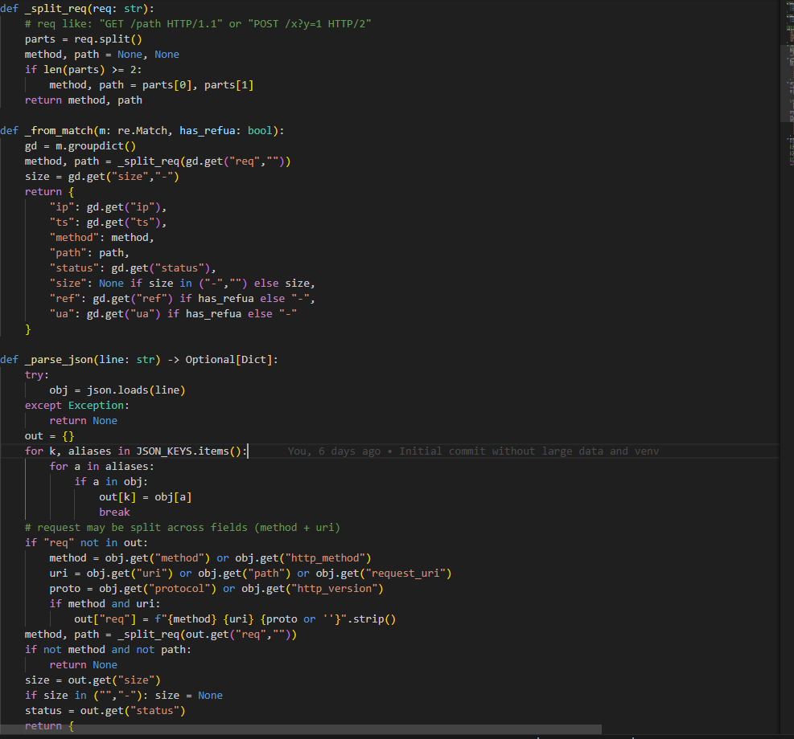
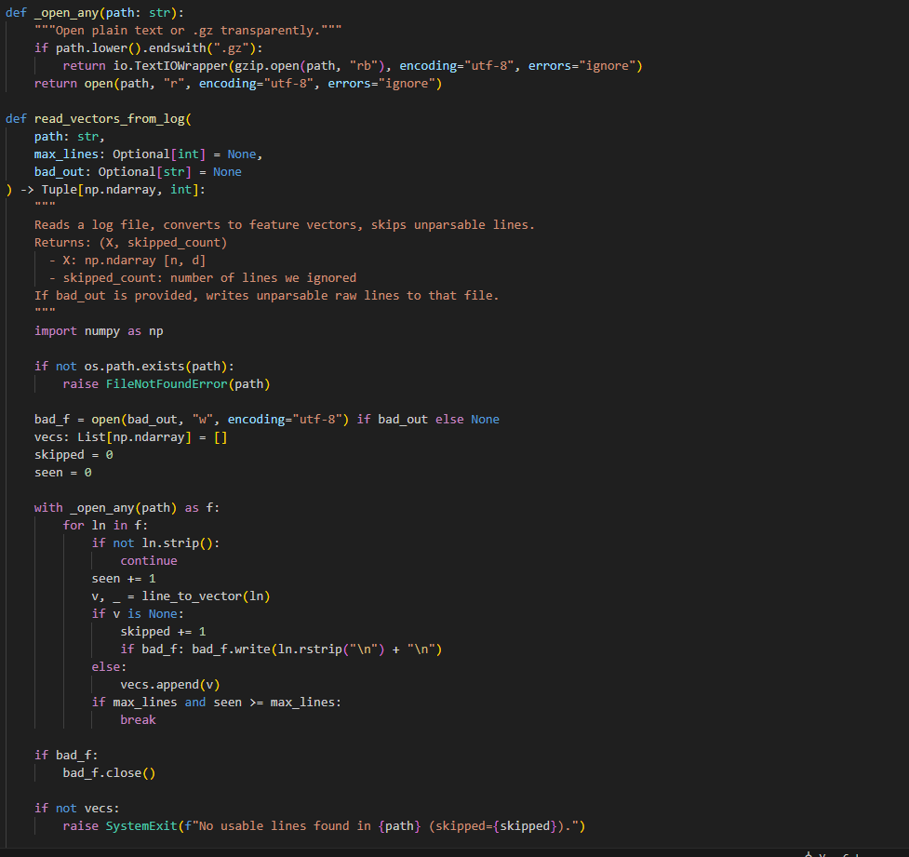
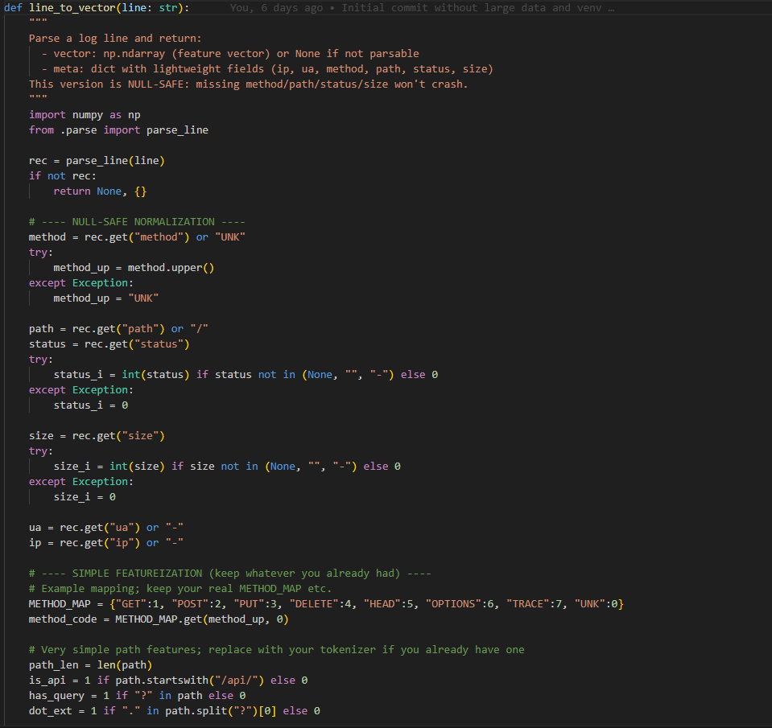

Appendix A.2:
Content-based autoencoder architecture and reconstruction-based anomaly scoring.
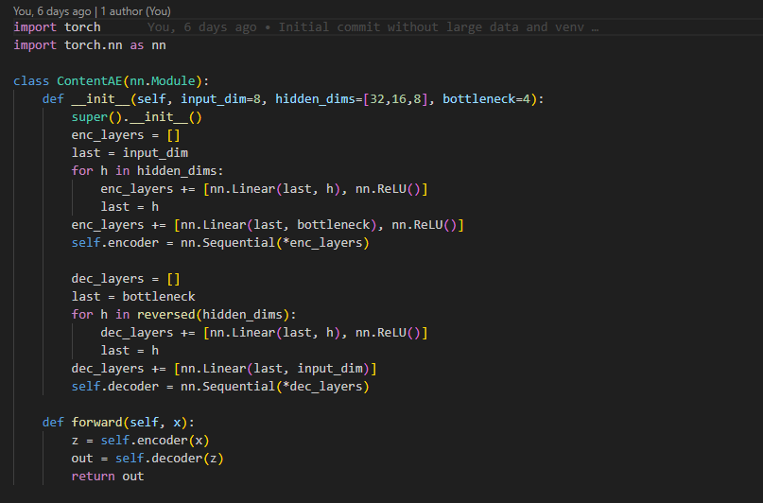

Appendix A.3:
LSTM variational autoencoder for session-level behavioural modelling.
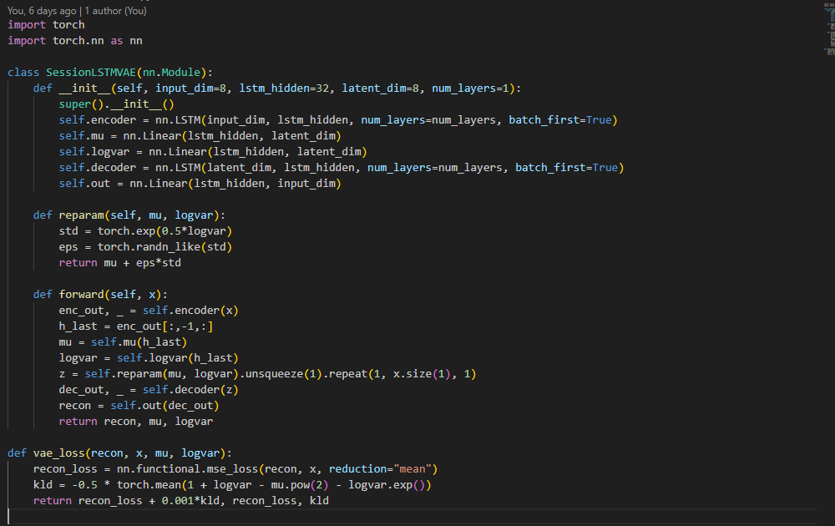

Appendix A.4:
Fusion of content-based and behaviour-based anomaly scores.
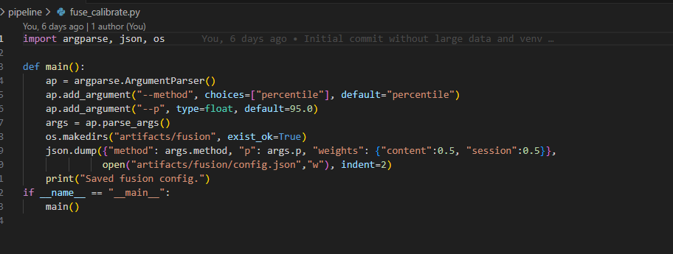
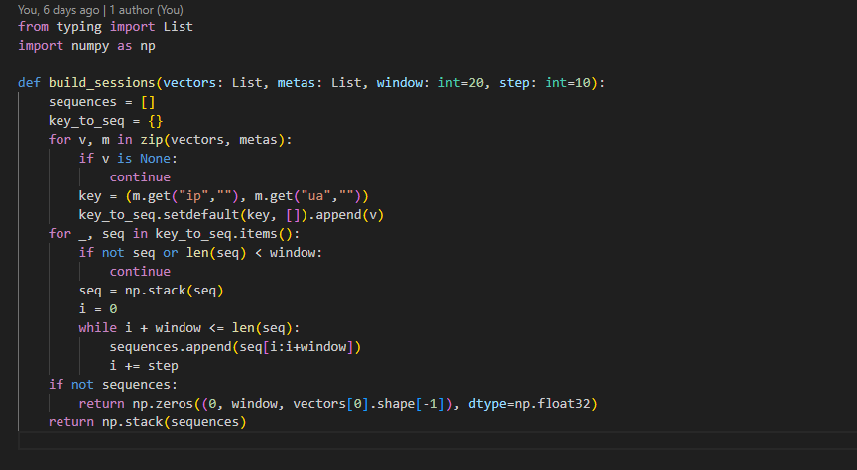

Appendix A.5:
Conservative percentile-based thresholding and evaluation metrics.
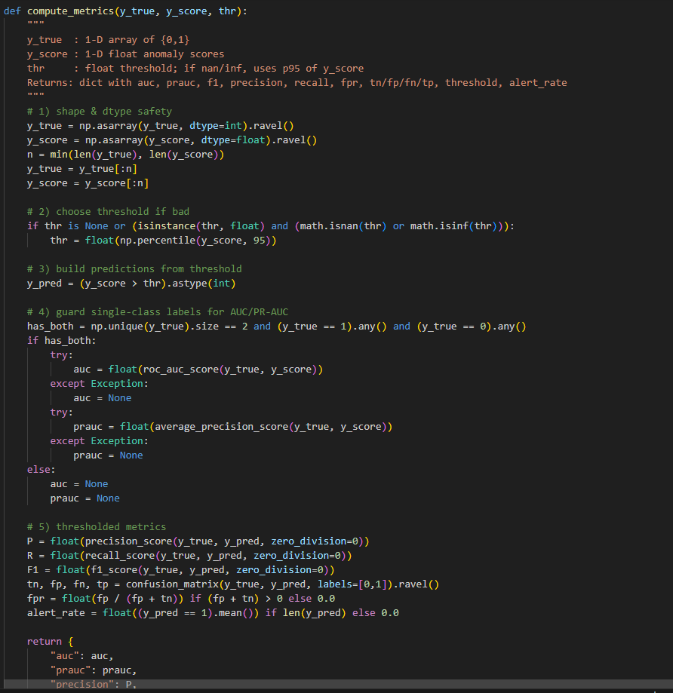
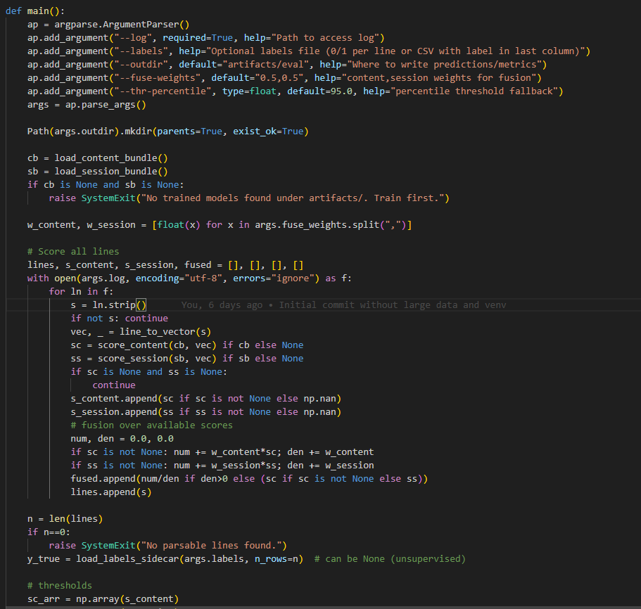

Appendix A.6:
Visual analytics used to interpret anomaly score distributions.
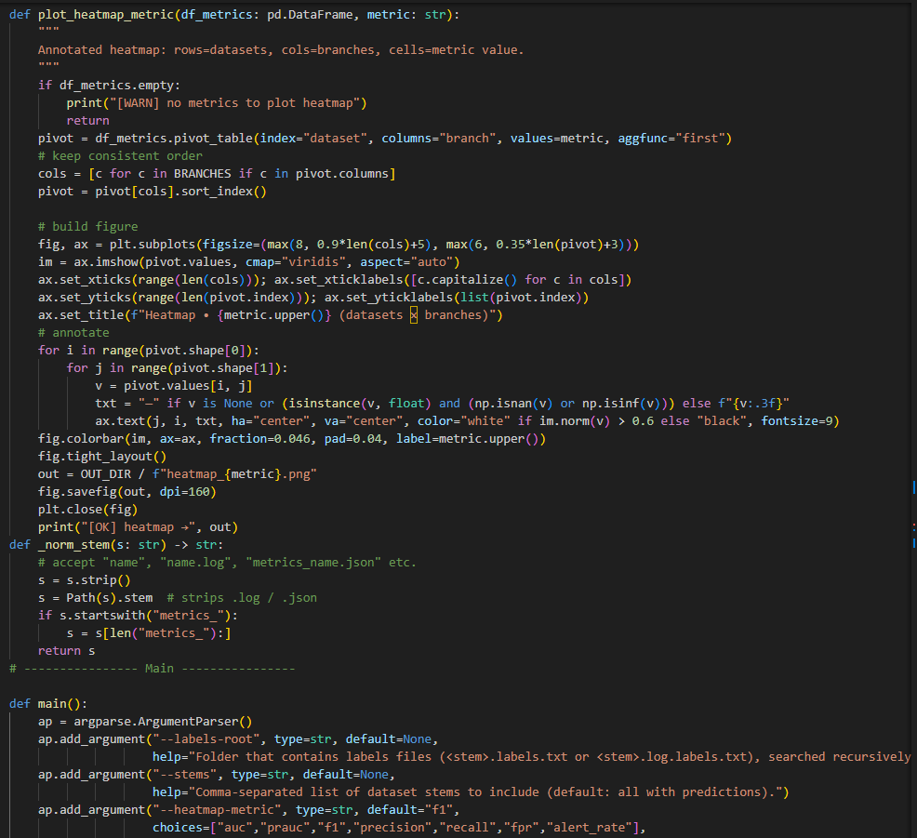

Appendix-B Process Documentation

Appendix B.1: Month of September Report Project Process Document 1
MSc PROJECT (COMP11024)

PROJECT PROCESS DOCUMENTATION

Student: Abdul Rehman Supervisor: Dr. Raja Ujjan

Total Meetings: 03 Date/Time: 16th,23rd,30th Sept 2025

Discussion or Agenda of the Meetings:
During the month of September, I had a discussion with my supervisor, Dr. Raja Ujjan about the dissertation proposal topic and objectives: Anomaly Detection in Web & Application Logs using LSTM & Autoencoder Models. The scope of the overall research has been narrowed down, and the study objectives have been well defined. The requirements for the interim report have also been defined that include a clear statement of the problem, research questions, and the study aims. I have been instructed to ensure that the project is of practical nature and reproducible.
Summary of agreed action plan:
- Finalise problem statement and research questions
- Define dissertation objectives and scope
- Draft a high-level system overview
- Plan reproducibility strategy (environment setup, seeds, version control)

Notes:
- Supervisor stressed the importance of reproducibility and clear documentation
- Early planning for Docker and environment consistency was encouraged

Appendix B.2: Month of October Report Project Process Document 2
MSc PROJECT (COMP11024)

PROJECT PROCESS DOCUMENTATION

Student: Abdul Rehman Supervisor: Dr. Raja Ujjan

Total Meetings: 04 Date/Time: 7,14th, 21st, 28th Oct 2025

Discussion or Agenda of the Meetings:
October was spent on performing a more focused literature review, which involved reviewing classical machine learning techniques as well as related deep learning based anomaly detection work. This was necessary to rationalize the approach taken and to outline the shortfalls in the current research. Alongside this, a structure for the methodology chapter was created which included data collection, data pre-processing and feature extraction, and lastly evaluation metrics.
Summary of agreed action plan:
- Complete literature review with relevant citations
- Compare traditional and deep learning approaches
- Draft methodology structure
- Identify datasets and evaluation metrics

Notes:
- Supervisor advised avoiding unnecessary theory and focusing on relevant work
- Literature should directly support design choices in later chapters

Appendix B.3: Month of November Report Project Process Document 3
MSc PROJECT (COMP11024)

PROJECT PROCESS DOCUMENTATION

Student: Abdul Rehman Supervisor: Dr. Raja Ujjan

Total Meetings: 04 Date/Time: 4,11th, 18th, 25th Nov 2025

Discussion or Agenda of the Meetings:
Reviewed the project codebase with Dr. Raja Ujjan in November. Examined the anomaly detection pipeline, covering both content-based and behaviour based models. Offered suggestions on model architecture, data preprocessing, and evaluation logic. Refinements to the code were made based on the review for clarity, correctness, and alignment with the research goals.
Summary of agreed action plan:
- Refine model implementation
- Improve preprocessing and session construction logic
- Validate evaluation methodology
- Align implementation details with dissertation chapters
Notes:
- Supervisor highlighted the importance of consistency between code and report
- Clear explanations of model behaviour were required in the results chapter

Appendix B.4: Month of December Report Project Process Document 4
MSc PROJECT (COMP11024)

PROJECT PROCESS DOCUMENTATION

Student: Abdul Rehman Supervisor: Dr. Raja Ujjan

Total Meetings: 02 Date/Time: 2,9th Dec 2025

Discussion or Agenda of the Meetings:
The December Month was directed to final dissertation writing and polishing. The report was reviewed chapter by chapter, up to Chapter 9. Comments were given on clarity, academic tone, structure, and presentation of results. Changes were made to reduce redundancy, improve flow, and enhance the discussion and conclusions. Final checks were done for adherence to academic standards.
Summary of agreed action plan:
- Finalise all dissertation chapters
- Reduce word count and remove redundant sections
- Ensure consistent formatting and referencing
- Prepare final submission

Notes:
- Supervisor advised prioritising clarity over complexity
- Results and conclusions should clearly reflect research questions

Appendix-C Approved Project Specifications File
Project Approved Specifications file

University of the West of Scotland
School of Computing, Engineering and Physical Sciences

MEng/MSc Cyber Security Project Specification

Student name: Abdul Rehman
Banner ID: B01753459
Email: B01753459@studentmail.uws.ac.uk / abdulrehmankhokhar25@gmail.com
Project being undertaken on part-time or full-time basis: Full Time
MEng/MSc Programme/stream: Cyber Security
MEng/MSc Programme Leader: Dr. Raja Ujjan

Project Title:
Web Server/Application Log Anomaly Detection using Deep Machine Learning LSTM or Autoencoders Algorithms

Research Question to be answered:
How Deep Machine Learning semi-supervised LSTM and Autoencoder algorithms can be utilised to feasible detect security relevant anomalies in the real world web server (Nginx/Apache) logs and web application logs?

Outline (overview) and overall aim of project:
Main aim of this project is to build a real world production feasible anomaly detection system for the Web Servers (Nginx/Apache) and web app logs that’s going to learn from the normal behaviour from mostly benign data and flags attacks, breaches, and abnormal usage.
The core will be consisted of a dual branch deep model, (1) a sequence (LSTM/VAE) branch for user’s sessions behaviour and (2) a content autoencoder branch for request payload, fields benchmarked against the string baselines on real world multi-site logs and public HTTP datasets.

This project will help to easily identify the loopholes in the web server configurations for security and the web applications security measures, which will help to strengthen them with more secure and reliable configurations.

Objectives (list of tasks to be undertaken to achieve overall aim of the project and to answer the research question posed):

Literature Review
- Systematically search IEEE Xplore, MDPI, ACM DL, Google Scholar (2017–2025).
- Build a comparison matrix (datasets, parsing/sessionization, model type, training regime, metrics, runtime limits).
- Synthesize gaps and define the proposed method and hypotheses.
- Outputs: 2-page summary, annotated bibliography, comparison table.
Dataset & Test-bed (no ethics/PII)
- Select public HTTP/web-log datasets (e.g., CSIC-2010, a public web-server log/Kaggle).
- Create a local Nginx/Apache test-bed to generate benign traffic (Locust/ab) and safe, controlled attacks (OWASP ZAP).
- Parse (Drain/Spell), sessionize (IP+UA/cookie, time gaps), redact PII; create time-based and cross-site splits.
- Outputs: Dataset card, preprocessing scripts, train/val/test files.
Design & Development (end-to-end pipeline)
- Implement ingest → parse → features → models → thresholding → alerts (Python, PyTorch, pandas; VS Code/Jupyter; Docker).
- Models: LSTM-VAE for session behavior + Autoencoder for request content; calibrated score fusion; EVT/POT thresholds.
- Expose a real-time scorer (FastAPI) and minimal alert endpoint/dashboard.
- Outputs: Clean Git repo, Dockerfile, configs, API docs, runnable demo.
Evaluation & Reporting (outperform baselines)
- Baselines: Isolation Forest, One-Class SVM, payload-attention model, Sec2vec-style embedding + classifier.
- Metrics: PR-AUC, F1 at fixed alert rate, alerts per million (A/M), p50/p95 latency, throughput, drift robustness.
- Ablations: parser choice, sessionization on/off, AE vs VAE, fusion vs single branch, window sizes, thresholding (EVT vs percentile).
- Visualize with Matplotlib/Plotly; export tables to Excel/CSV; add token/field-level explanations.
- Outputs: Results notebooks, figures, tables, concise findings page.

CyBOK Knowledge Areas (Please check at least two relevant areas your project going to be covered):

Human, Organisational & Regulatory Aspects | ☐ | Risk Management & Governance
 | ☐ | Law & Regulation
 | ☐ | Human Factors
 | ☐ | Privacy & Online Rights
Attacks & Defences | ☐ | Malware & Attack Technologies
 | ☐ | Adversarial Behaviours
 | ☐ | Security Operations & Incident Management
 | ☐ | Forensics
Systems Security | ☐ | Cryptography
 | ☐ | Operating Systems & Virtualisation Security
 | ☒ | Distributed Systems Security
 | ☐ | Formal Methods for Security
 | ☐ | Authentication, Authorisation & Accountability
Software and Platform Security | ☒ | Software Security
 | ☒ | Web & Mobile Security
 | ☒ | Secure Software Lifecycle
Infrastructure Security | ☐ | Applied Cryptography
 | ☒ | Network Security
 | ☐ | Hardware Security
 | ☐ | Cyber Physical Systems
 | ☐ | Physical Layer and Telecommunications Security

Indicative reading list (references to be correctly presented) and resources:
Benova, L. and Hudec, L. (2024) ‘Comprehensive Analysis and Evaluation of Anomalous User Activity in Web Server Logs’, Sensors, 24, 746. https://www.mdpi.com/1424-8220/24/3/746

Chovanec, M., Hasin, M., Havrilla, M. and Chovancová, E. (2023) ‘Detection of HTTP DDoS Attacks Using NFStream and TensorFlow’, Applied Sciences, 13, 6671. https://www.mdpi.com/2076-3417/13/11/6671

Chua, W., Pajas, A.L.D., Castro, C.S. et al. (2024) ‘Web Traffic Anomaly Detection Using Isolation Forest’, Informatics, 11, 83. https://www.mdpi.com/2227-9709/11/4/83

Gniewkowski, M., Maciejewski, H., Surmacz, T. and Walentynowicz, W. (2021) HTTP2vec: Embedding of HTTP Requests for Detection of Anomalous Traffic. arXiv preprint arXiv:2108.01763. https://arxiv.org/abs/2108.01763

Gniewkowski, M., Maciejewski, H., Surmacz, T. and Walentynowicz, W. (2023) ‘Sec2vec: Anomaly Detection in HTTP Traffic and Malicious URLs’, in Proceedings of the 38th ACM/SIGAPP Symposium on Applied Computing (SAC ’23), Tallinn, Estonia, 27–31 March 2023, pp. 1154–1162. https://dl.acm.org/doi/10.1145/3555776.3577663

Jagat, R.R., Sisodia, D.S. and Singh, P. (2024) ‘Detecting Web Attacks From HTTP Weblogs Using Variational LSTM Autoencoder Deviation Network’, IEEE Transactions on Services Computing, 17(5), pp. 2210–2221.https:/ieeexplore.ieee.org/document/10669063

Liu, T., Qi, Y., Shi, L. and Yan, J. (2019) ‘Locate-Then-Detect: Real-time Web Attack Detection via Attention-based Deep Neural Networks’, in Proceedings of the Twenty-Eighth International Joint Conference on Artificial Intelligence (IJCAI-19), pp. 4725–4730. https://www.ijcai.org/proceedings/2019/0656.pdf

Wasundara, M.I., Zhou, J., Yang, Y., Zhao, D. and Xiang, J. (2025) ‘Semi-supervised method for anomaly detection in HTTP traffic’, EURASIP Journal on Information Security, 2025, 25. https://jis-eurasipjournals.springeropen.com/articles/10.1186/s13635-025-00210-w

Marking scheme:
Introduction 5%
Context – literature review 20%
Research Design 10%
Implementation (practical work) 20%
Evaluation 15%
Presentation of results 10%
Conclusions and recommendations 10%
Critical self-evaluation 10%

Supervisor:
Dr. Raja Ujjan

Moderator:

Programme Leader:
Dr. Raja Ujjan

Date specification submitted:

Please complete the ‘ethics’ form below for all projects.

School of Computing, Engineering and Physical Sciences
MSc PROJECT – REQUIREMENT FOR ETHICAL APPROVAL

SECTION 1: TO BE COMPLETED BY THE STUDENT

Please answer the following questions: | Select Yes or No
Does your project involve: human subjects (e.g. as clients, providers of requirements, ‘testers’/users), access to unpublished company documents/records, private personal data, questionnaires, surveys, focus groups and/or other interview techniques? | No
If your answer above is Yes, have you discussed with your supervisor and applied for ethical approval using the university’s Ethical Review Manager online system? | No
If you haven’t applied for the ethical approval, have you started preparing necessary documents required for the ethical approval, e.g. information sheet, consent form, questionnaires, etc? | No
I confirm that I will not start the above mentioned project work before obtaining formal ethical approval. | No

If answering yes to the first question above, and if you have not done so already, please prepare and submit an application for ethical approval through the university’s “Ethical Review Manager” (ERM) system, which is available at https://uws.forms.ethicalreviewmanager.com.

Before doing so, please consult the ERM applicant user guide, which can be downloaded from: https://www.uws.ac.uk/media/5364/erm-applicant-user-guide.pdf
The process for making applications and the principles applied in the School of CEPS are contained within the Ethical Approval Process. Please read this document before making an application for ethical approval.
Please provide any additional information, comments and suggestions:

Name of Student (Print name):

Signature:
Date: 03/10/2025
SECTION 2: TO BE COMPLETED BY THE PROJECT SUPERVISOR
I understand that the above project requires/does not require* ethical approval (*please delete as appropriate).

Supervisor : Raja Ujjan

Signature:

Date: 02/10/2025

IMPORTANT: please note that by signing this form all signatories are confirming that any potential ethical issues have been considered and, where necessary, an application for ethical approval has been/will be made via the Ethical Review Manager software.
Any project requiring ethical approval, but which has not been given approval will not be accepted for marking.

